Aurora borealis
(Northern lights)
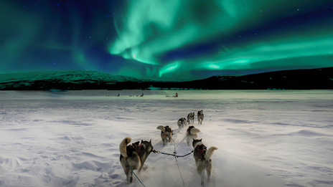 | What are the northern lights?  The northern lights are bright streams of light created by charged particles from the sun striking atoms in Earths atmosphere.  The lights show up at night when the sky is dark. It’s like a celestial ballet of light dancing across the night sky, with a colour palette of green, blue, pink, and violet.
Aurora:  An aurora, sometimes referred to as polar lights, northern lights, or southern lights, is a natural light display in the Earth's sky, predominantly seen in high-latitude regions. Auroras are the result of disturbances in the magnetosphere caused by solar wind. | 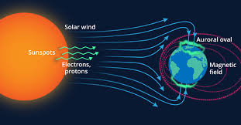
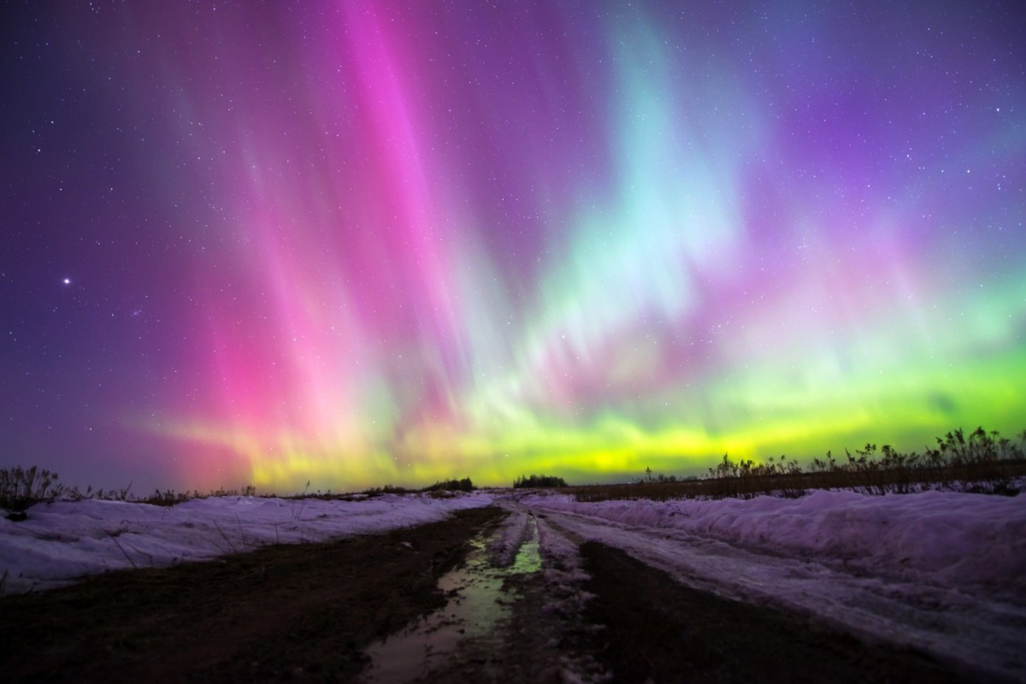 | Where and when:  The northern lights are most commonly found in Finland, Greenland ,Lapland, Norway and Iceland.  To witness them in all their glory requires patience and the following conditions to be met:  - You must be visiting between September and April  - The night must be as dark as possible  - There should be as little unnatural light as possible  - There should be as little cloud cover as possible  - There must be enough solar activity

