Spidey Star Jumps  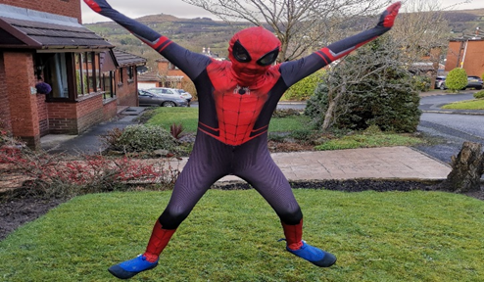  Now here is one Spidey quite likes!  The Spidey star jumps. What you have to do is you have to do a star jump and then shoot a web at a tree (You don’t need to shoot a web, you can just use some string, I shoot webs though) and try and do ten. This exercise does not need any equipment and you can do as many as you want.  Web Head Cyclist  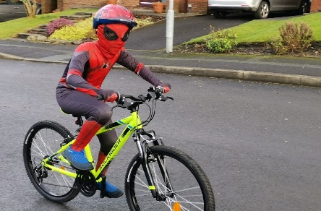  Keep pedalling for a healthy heart. Give your legs some exercise. What you have got to do is cycle around your street and push your legs like Spidey in the picture. You need a bike and a helmet but no more equipment is needed. | Keeping Fit Spidey Style  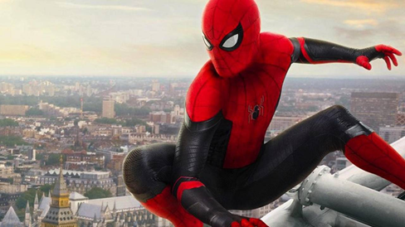  Are you tired of keeping fit normally, going out on walks and all that?  Do you like superheroes?  Well you picked up the right leaflet. Spidey is going to help to bring your superhero dreams to life and follow his advice and you will be able to become your own Spider-Man or Women.  Ready to get started?  I know me and Spidey are.  Lets get started!  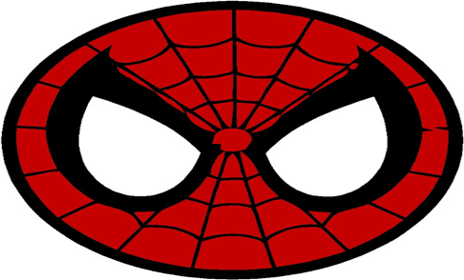 | Web Runners  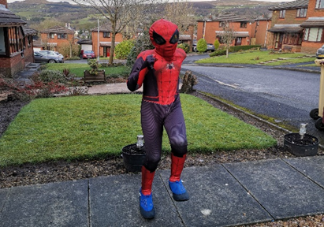  Now to keep running and to patrol your  neighbourhood, you can run around or do  running on the spot and its good to keep  your heart beating and it keeps you healthy. It’s good and doesn’t need any equipment including a suit.  Web Slinger  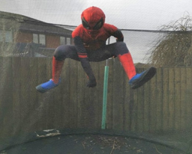  You need a trampoline to perform this activity. You can do any trick and jump as many times as you want but you need to do a few good jumps to get you going.

