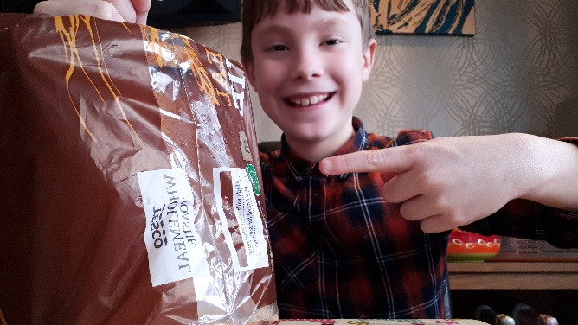  CARBOHYDRATES  Carbohydrates give people energy for everyday activities and they help the internal body functions.  If you eat too many carbohydrates, you will become vulnerable to heart disease and diabetes, and they can make you fat . If you don’t have enough carbohydrates, you will be very low on energy which will make you not want to do things.  Examples of Carbohydrates:  - Bread (white brown e.g.)  - sugar  - potatoes  - pasta  - rice  - porridge oats  - cereal  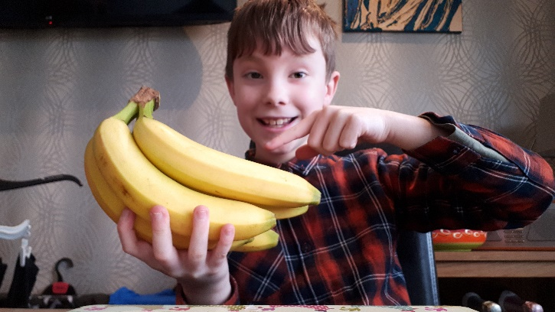  FRUIT AND VEGETABLES  Fruit and veg are a key part in our diet and if you have five a day (Different fruit and vegetables not the same), you will be healthy.  If you have too much fruit, it is full of sugar which is really bad for you. If you don’t have enough fruit and veg, you won’t really be healthy and you will have to rely on being fit.  Examples of Fruit and veg  - bananas ● strawberries  - tomatoes ● raspberries  - apples  - pears  - oranges  - peas  - broccoili  - carrots | HEALTHY FOODS  There are five food groups. The groups of the delicious food are listed at either side of this paragraph telling you what they are, examples of the each food group, and what happens if you eat too much or not enough.  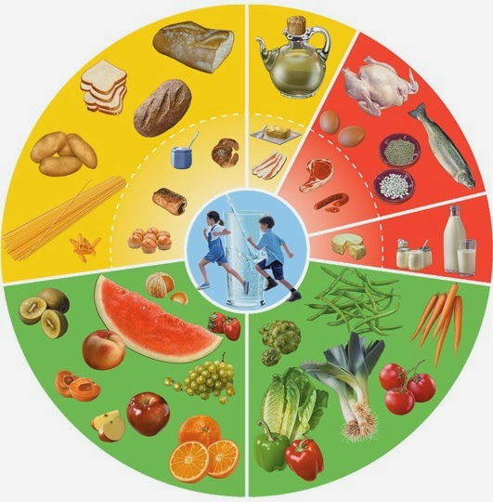  DAIRY  Dairy holds vitamins and calcium. It helps to strengthen the bones. If you eat too many dairy treats, you can suffer from diarrhoea and if you don’t eat enough, you can suffer from lots of diseases and one of them is cancer and osteoporosis.  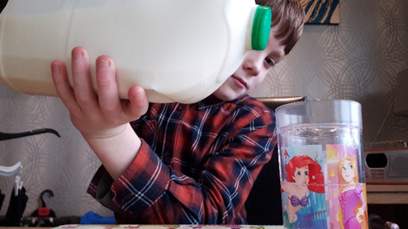  Examples of Dairy:  - eggs  - cheese  - milk  - butter  - coconut | 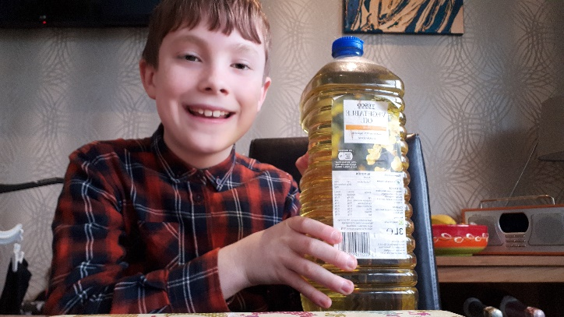  FATS AND OILS  Fats and oils supply energy to us and help us absorb vitamins. Oils can be used for cooking. Fat can be used in things like butter and cheese.  If you eat too much fat, you become fat, are at higher risk of cancer, heart disease and atherosclerosis . If you don’t have enough of the right type of fat, you will lack energy and will not be able to absorb vitamins.  Examples of good fat:  - olive oil  - avocado  - nuts  Examples of bad fat:  - butter  - cheese  - red meat (beef’ lamb’ pork etc.)    PROTEINS  Proteins are used to grow and repair us. They make new cells in our bodies and help regenerate cells.  If you eat too much protein, it is stored as fat and can give you constipation.

