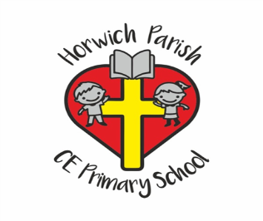

Year 6

Summer 1

PE

We will be performing a street dance with Junior Jam

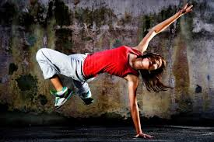

RE

What kind of king is Jesus?

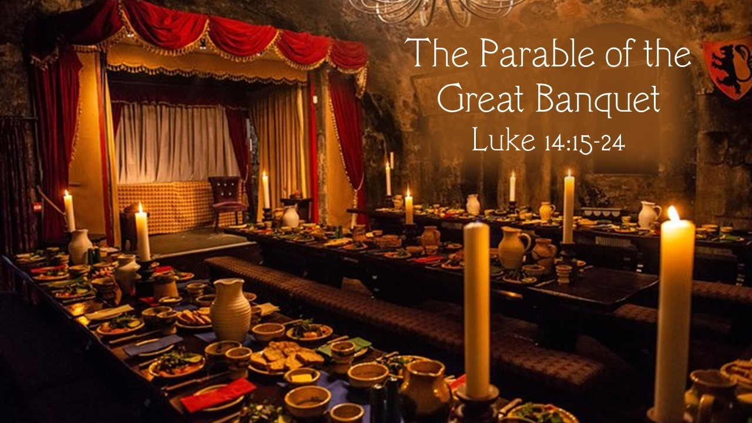

PSHE

Recognising the role of pressure groups and understanding diversity



Music

Samba Drumming

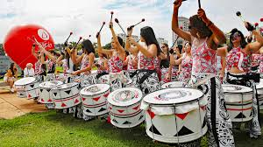

Art

Drawing – making our voices heard

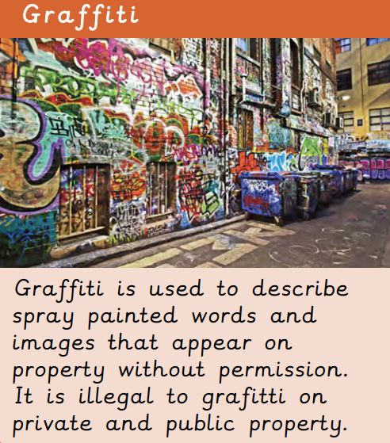

History

Who should go on the £10 banknote?

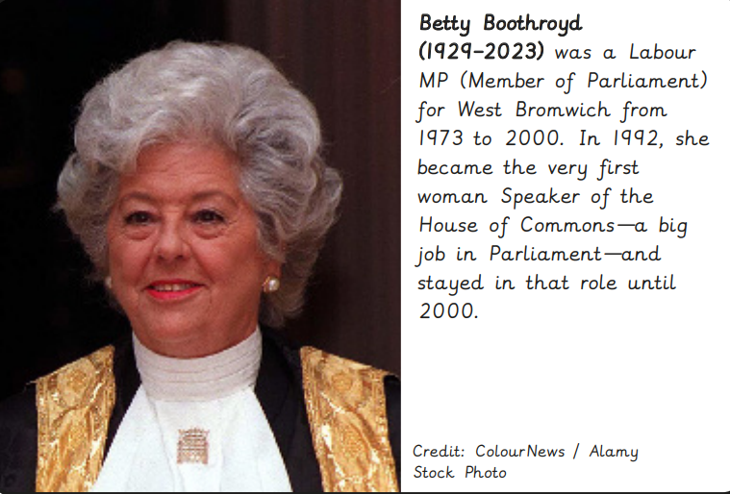

Science

Which characteristics are inherited and what is evolution?

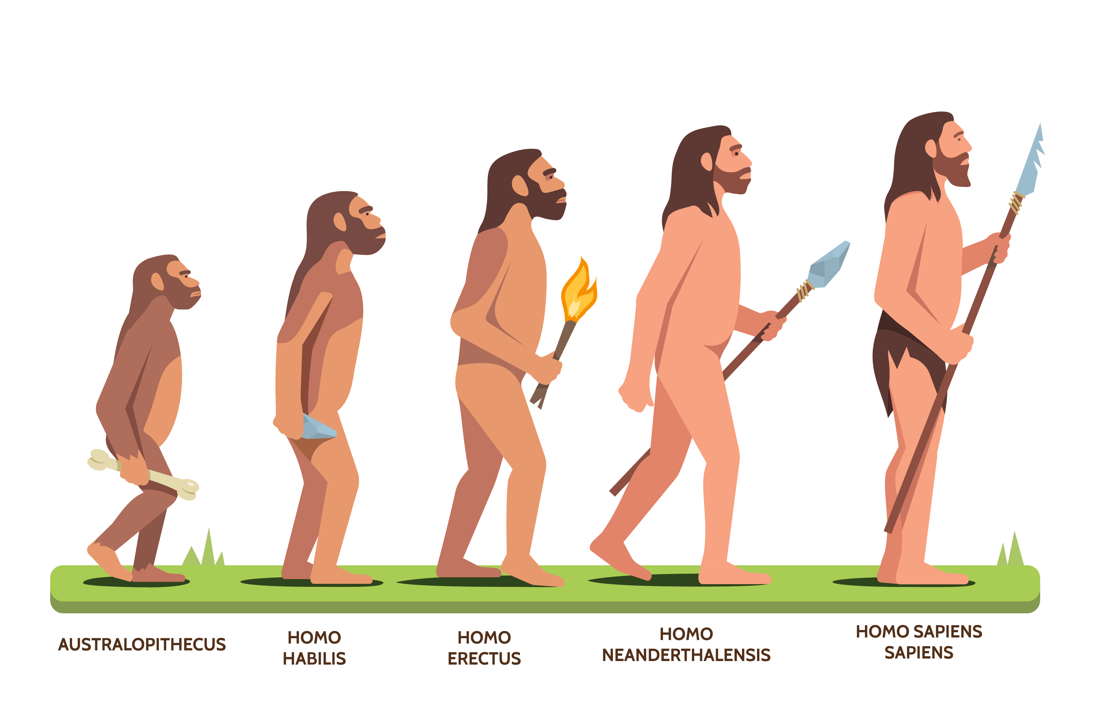

Maths

We will be measuring and classifying angles and finding out about the properties of circles and quadrilaterals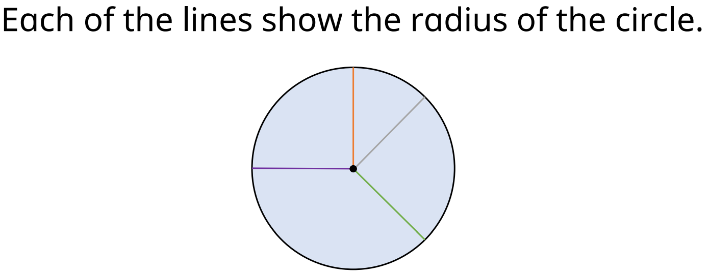

Computing

Creating Media – Website Design

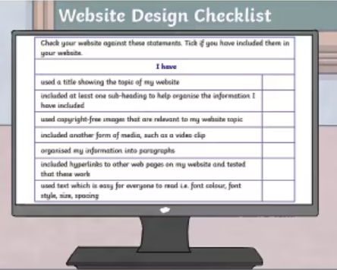

English

In our writing, we will be using dialogue to advance the action in Broken: Rock, Paper, Scissors

