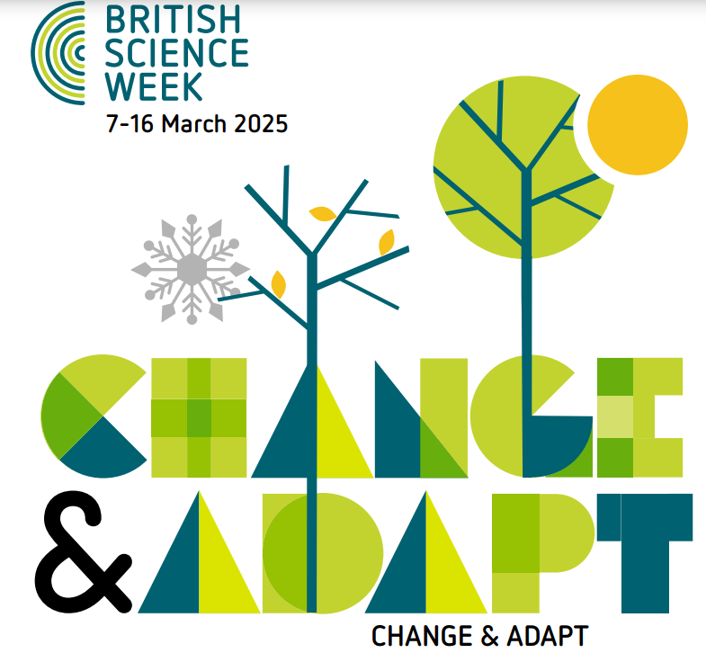

Horwich Parish Science day Monday 10th March 2025

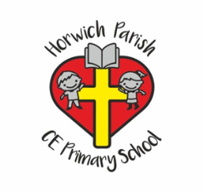

As part of British Science week we are celebrating a science day on Monday 10th March. This year’s theme is ‘Change and Adapt’. We will be planning a day filled with activities which promote cross-curricular learning and break down the stereotypes surrounding science, technology, engineering and maths (STEM). We will be using British Science Week as an opportunity to link STEM to other curriculum subjects and to the children’s interests.

During the week, we will have a science gadget shop after school on Tuesday 11th, Wednesday 12th and Thursday 13th March from 3.20 to 3.45pm in the year 4 intervention room. There will be many exciting items on sale ranging from stretchy lizards priced at 50p to a crystal growing kit priced £2 each.  There will also be raffle tickets on sale at 50p each for the chance to win a set of 6 science experiments worth over £20. We hope that you can bring your child along to choose an item or two to stimulate their inquiring, scientific minds.

Everyone is invited to dress up as a scientist or anything linked to science for the day, there is no cost for this. Children should come in school uniform if they do not wish to dress up.

  

 