Ppppkhgdedsa

**English**

**Write a recount of Shackleton’s expedition to the Antarctic**

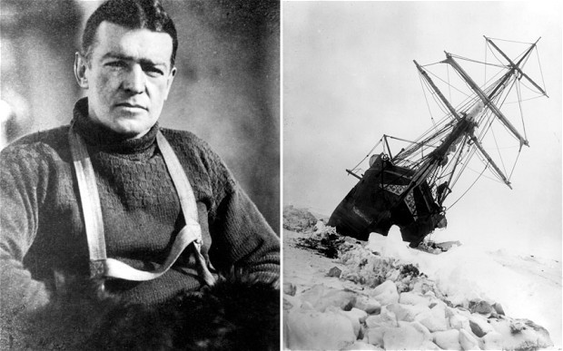

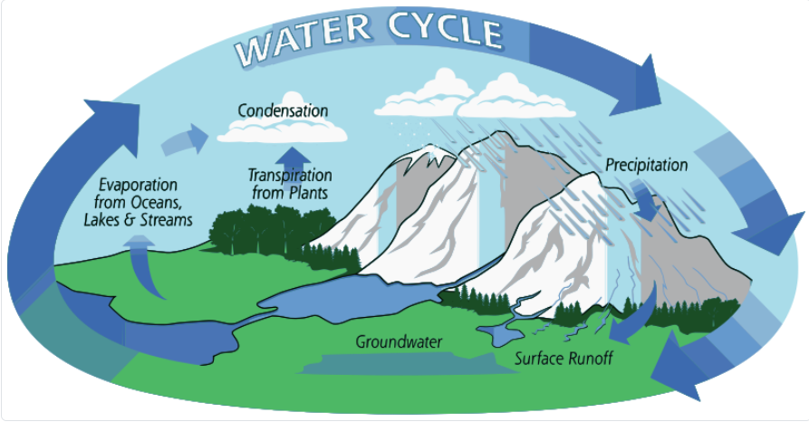

Design Technology

Making a pop-up card

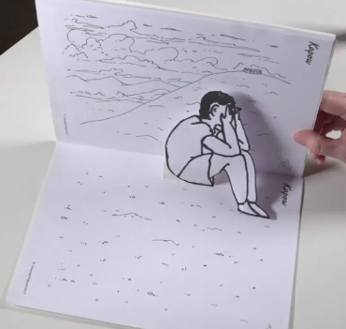

**Art**

**Drawing**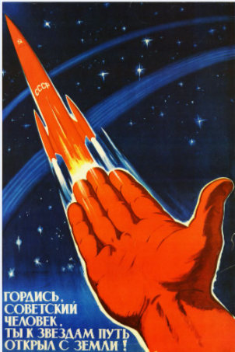

**Science**

**Electrical Circuits**

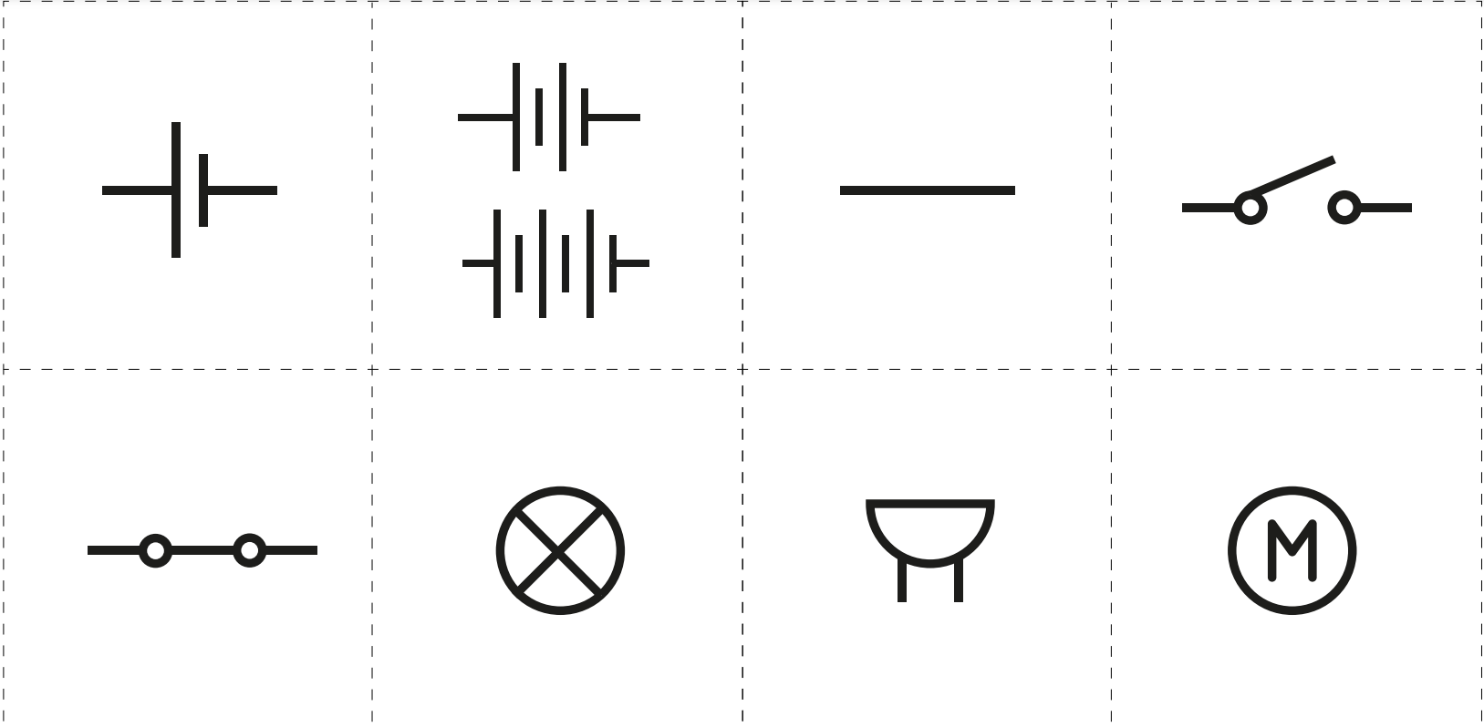

**Religious Education**

**What difference does the resurrection make to Christians?**





PSHE - Puberty

Puberty

**Computing**

**How to use a microbit**

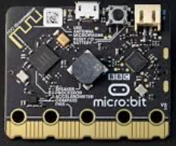

**P.E.**

**Striking and fielding**

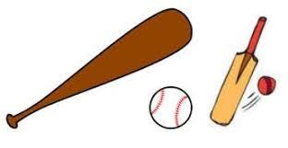

Geography

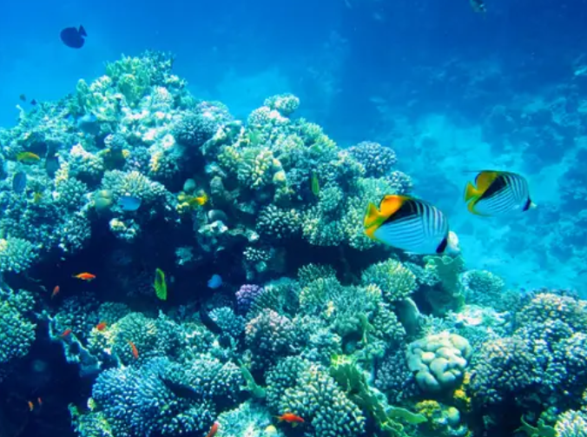

**Maths**

**Fractions, decimals, percentages**

**Area and perimeter**

