Ppppkhgdedsa

**English**

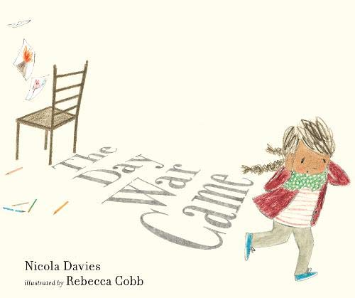

**Write a letter and a diary entry linked to refugees and evacuees**

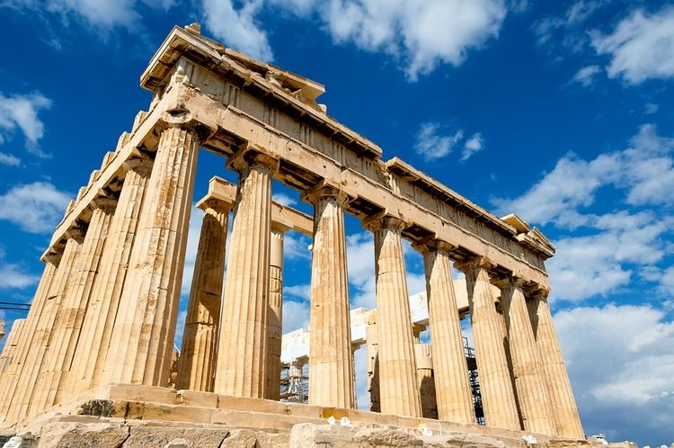

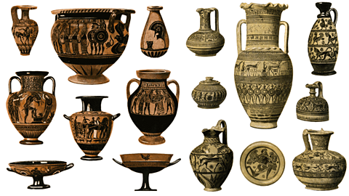

**Art**

**Sculpture**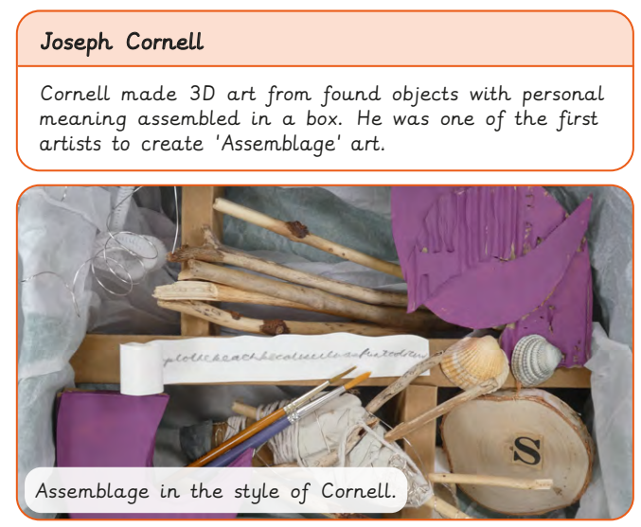

**Science**

**Healthy lifestyles**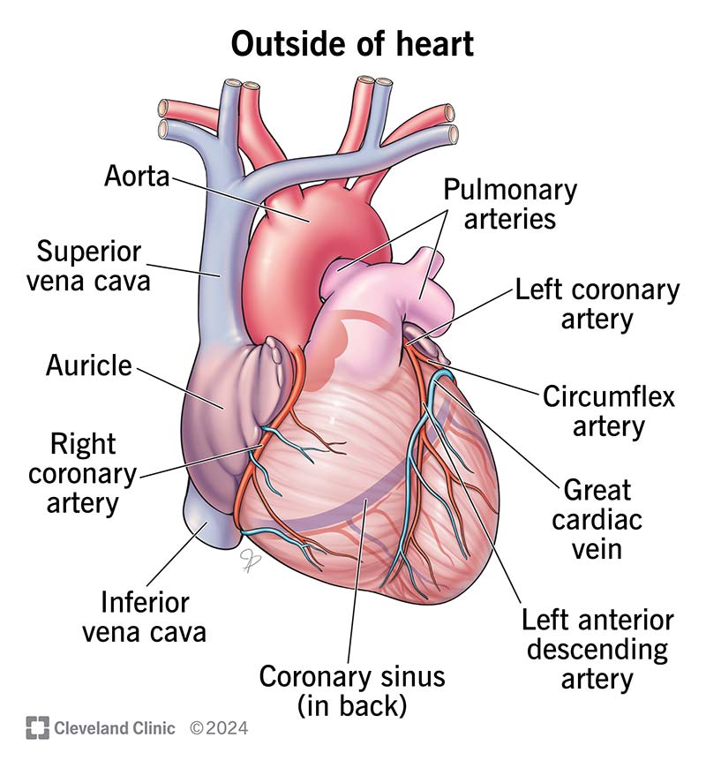

**Religious Education**

**Why might following God bring freedom and justice?** 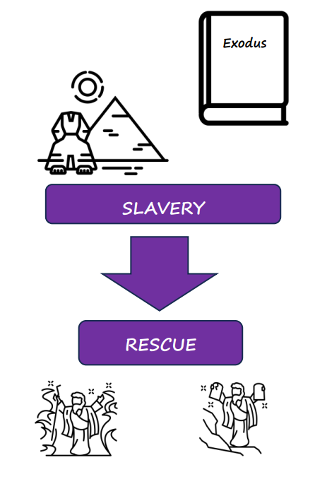

PSHE

Health and wellbeing – relaxation and sleep

**Computing Coding**



**P.E.**

**Attacking and defending**

History

Placing events in chronological order

Using primary and secondary sources

How did the war affect the people of Horwich?

**Maths**

**Ratio**

**Algebra**

