July 2024 | EVIDENCING THE IMPACT OF PRIMARY PE AND SPORTS PREMIUM AT HORWICH PARISH CE SCHOOL 2023 - 2024  Stephen Banner – PE Coordinator

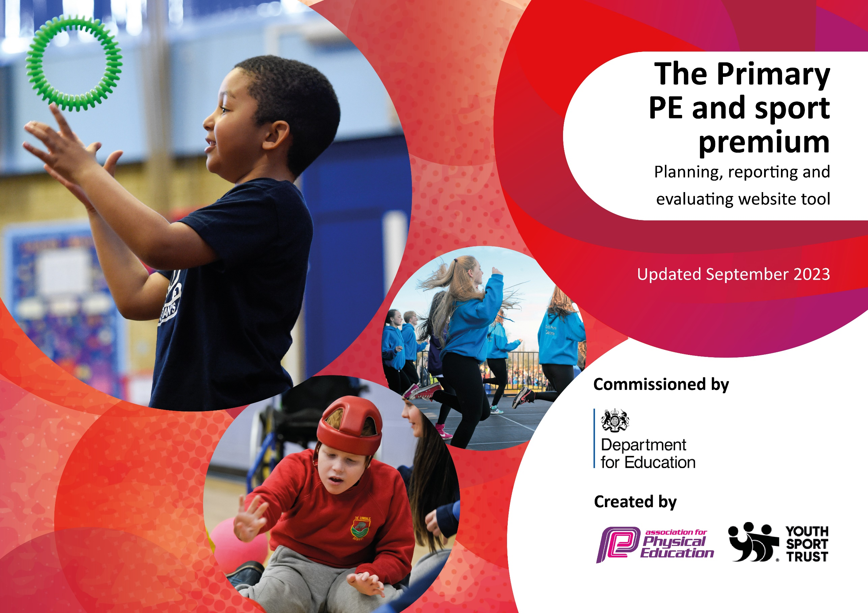

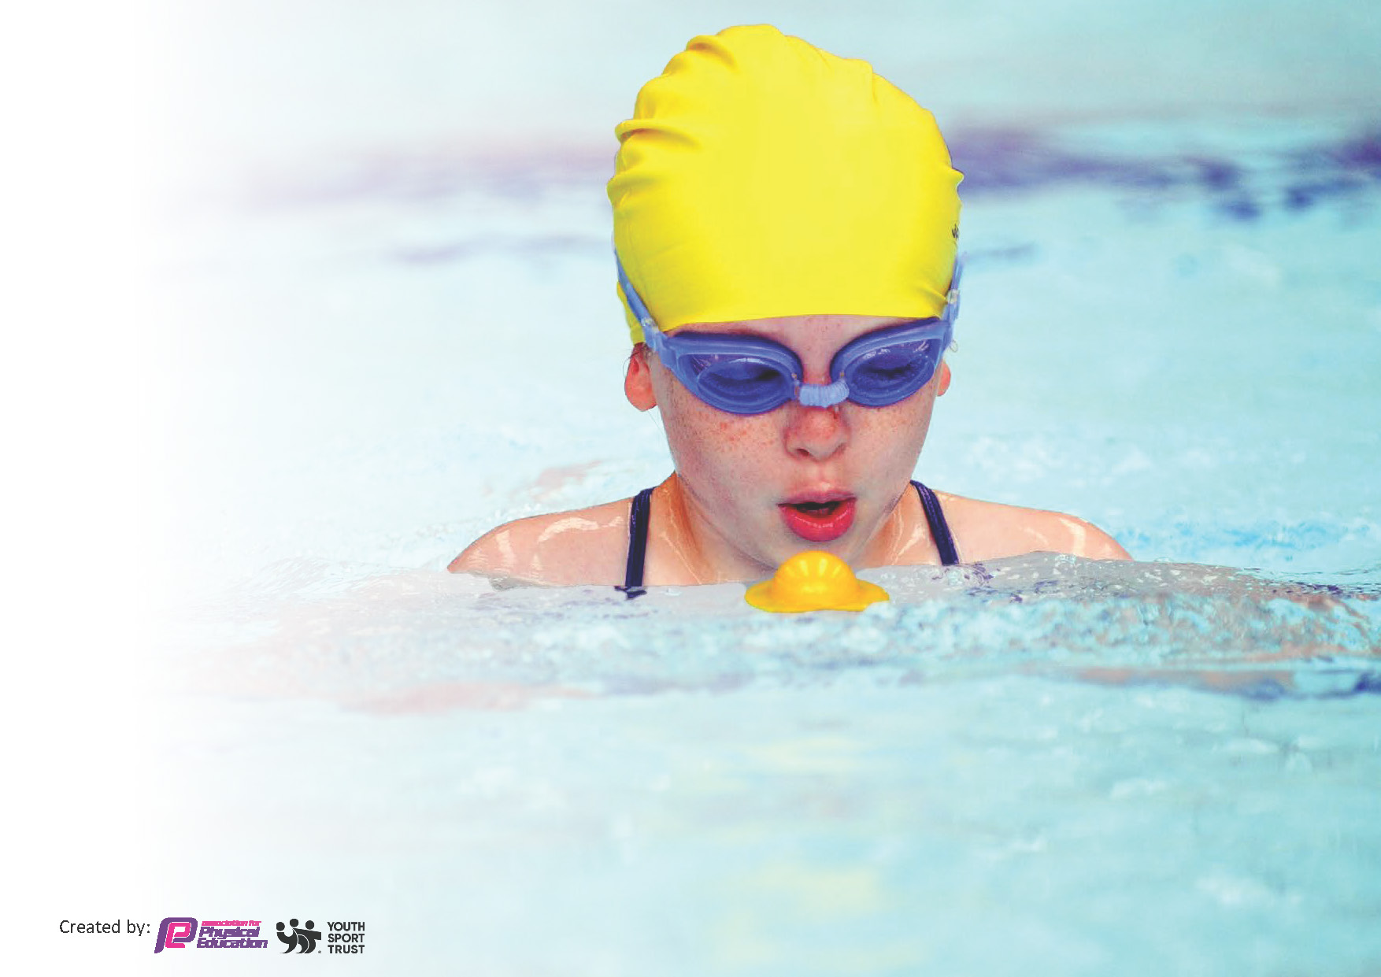
This template can be used for multiple purposes:
by:
- It enables schools to effectively plan their use of the Primary PE and sport premium
- It helps schools to meet the requirements (as set out in guidance) to publish information on their Primary PE and sport premium
- It will be an effective document to support Ofsted inspections enabling schools to evidence progress in Physical Education (PE) and evidence swimming attainment, which forms part of the PE National Curriculum. We would recommend schools consider
the Intent, Implementation and Impact of any spend, as examined within the Education Inspection Framework.

It is important that your grant is used effectively and based on school need.

Schools must use the funding to make additional and sustainable
improvements to the quality of the PE, School Sport and Physical Activity (PESSPA)
they offer. This means that you should use the Primary PE and sport premium to:

- Build capacity and capability within the school to ensure that improvements made now will benefit pupils joining the school in future years
- Develop or add to the PESSPA activities that your school already offers.

The Primary PE and sport premium should not be used to fund capital spend projects; the school’s core budget should fund these. Further detail on capital expenditure can be found in the updated Primary PE and sport premium guidance.

The Primary PE and sport premium guidance, outlines 5 key priorities that funding should be used towards. It is not

necessary that spending has to meet all the key priorities, you should select the priorities that you aim to use any funding towards.

Although completing this template is not a requirement for schools, schools are required to publish details of how they spend this funding. Schools must also outline what the impact this funding has had on pupils’ PE and sport participation and attainment and how any spending will be sustainable in the future. All funding must be spent by 31st July 2024.

The Department for Education has worked closely with the Association for Physical Education (afPE) and the Youth Sport Trust (YST) to develop this template and encourages schools to use it. This template is an effective way of meeting the reporting requirements of the Primary PE and sport premium.
Review of last year’s spend and key achievements (2022/2023)

We recommend you start by reflecting on the impact of current provision and reviewing your previous spend.

Activity/Action | Impact | Comments
The PE timetable ensures that all classes have two PE sessions each week.  The children have access to sports equipment during breaks.  Daily mile is completed on a regular basis by some year groups.  The use of imoves in class allows teachers to incorporate physical activity in the classroom during curriculum time.  SLA with specialist sports coaches for Reception – Y3.  The school takes part in the WOW scheme which tracks how children travel to school each day with a monthly reward for children who regularly walk or cycle to school.  The PE equipment in school was audited and replaced.  The school ensured a continuation of our extensive calendar of inter-school sporting competitions and intra-competitions.  Sports ambassadors in school designed and led a Reception level intra-sports event.  Yoga training will provide all staff a basic qualification that will give them the skills to teach yoga to the children of Horwich Parish.  Tom Luke Tennis – CPD in the instruction of cricket and tennis to children in KS1.  Key PE Sports – Sports coaching and CPD for all staff.  Additional achievements:  Horwich Parish has arranged a number of broader sporting experiences for the children at Horwich Parish:  - Colour Run (all pupils)  - Introduction to sailing (Y5/6)  - Qudditch Festival (all pupils)  - Boxing (Y3)  - Fencing (Y3) | Pupil questionnaires show evidence that children are confident that they have two PE lessons each week.  Increased pupil attendance at sports clubs outside of school.  Children at Horwich Parish state that the enjoy PE at their school.  Children are knowledgeable about key vocabulary in sport.  Horwich Parish has had a larger number of pupils entering inter-school competition this year.  WOW has been a success with Horwich Parish coming first out of the Bolton schools.  PE equipment is of a good standard and fit for its purpose.  Child voice states and enjoyment of the intra-school events on offer.  The colour run was a success and encouraged children to enjoy athletics.  The Year5/6 children enjoyed taking part of sports on open water and now have a greater appreciation of water based sports.  Staff are able to teach yoga.  Staff are more confident in the delivery of tennis and cricket.  Staff observing Key PE show increased confidence in the delivery of the school’s scheme of work. | PE continues to be enjoyed by pupils at HP.  The teaching of vocabulary continues to be a high priority at Horwich Parish.  The school continues to achieve Gold Award in the School Games Award.  The school continues to participate in the WOW challenge.  PE equipment is audited on a regular basis to ensure all PE lessons are properly resourced.  The school continues to seek new opportunities for the pupils.  ______________________________  Staff new to the school may need to complete Yoga level 1.

Key priorities and Planning
This planning template will allow schools to accurately plan their spending.

Action – what are you planning to do | Who does this action impact? | Key indicator to meet | Impacts and how sustainability will be achieved? | Cost linked to the action
- Update lunchtime sport activities and active opportunities for pupils.  - Provide expert coaching for all pupils at Horwich Parish.  - Ensure all children are active for the recommended time each day at Horwich Parish.  - Ensure all children experience a broad range of sports and activities at Horwich Parish.  - Ensure the school continues to take part in a variety of inter-school competition. | - Pupils as they take part in enjoyable active lunchtimes.  - Pupils, teachers and Key PE Sports Coaches.  - Pupils and staff.  - Pupils, Staff, Key PE Coaches, Tom Luke Tennis coaches and SGO.  - Pupils, staff and SGO.  - Teachers and Sports Coaches. | Increasing all staff’s confidence, knowledge and skills in teaching PE and sport  Increasing engagement of all pupils in regular physical activity and sport  Raising the profile of PE and sport across the school, to support whole school improvement leading to an improved  Offer a broader and more equal experience of a range of sports and physical activities to all pupils at Horwich Parish.  Increase participation in competitive sport amongst pupils at Horwich Parish CE School. | 1 Higher percentage of pupils being active during break and lunchtimes.  2. Increasing staff confidence, knowledge and skills in teaching PE and sport. (Staff questionnaire, lesson drop in, pupil voice)  3. Increasing engagement of all pupils in regular physical activity and sport. (PE timetable, monitoring from SLT to ensure daily mile is being carried out, active learning, PE lessons)  4/ 5. Offer a broader and more equal experience of a range of sports and physical activities to all pupils (Key PE Sports SLA, Tom Luke Tennis SLA, Chorley Sports Partnership SLA) | - Part of the Key PE SLA (£10,007 for the year).  - Part of the Key PE SLA (£10,007) / Tom Luke Tennis SLA (£4,400).  - Subject leader monitoring.  - Chorley Sports Partnership SLA (£1800)/ Bolton School Games (£100)  - Same costs as 4.

Key achievements 2023-2024
This template will be completed at the end of the academic year and will showcase the key achievements schools have made with their Primary PE and sport premium spending.

Activity/Action | Impact | Comments
Commando Joes: 1 x Coach 1 x Day per week between 8:30am and 4:15pm. 1 year SLA with Commando Joes with the aim of the coach working with all pupils at Horwich Parish with the aim of developing physical fitness, teamwork, resilience and problem solving abilities (£12,000)  Renewed SLA with Chorley Sports Partnership to arrange inter-school sports competitions for the entire academic year. Horwich Parish have enjoyed high levels of participation. Achieved Gold award in the school games mark. (£1,750)  Bolton Inter School Sports: We have renewed our annual agreement with Bolton School Games to compete in competitions (including SEND inclusive competitions) across Bolton. As part of this package, the sports lead was able to also attend the Annual Bolton School sports conference. (£100)  Tom Luke Tennis has provided expert coaching in tennis and cricket to all children in years R, 1 and 2. They have also provided an after school club that children in both KS1 and 2 have benefitted from. (£4550)  Sports Lane Markers for Sports Day (£235 - Estimated) | Children have participated in a wider variety of sports. They have participated in regular physical activity allowing them meet a large percentage of the recommended amount of daily physical activity. Sports coaches from Commando Joes also ran lunchtime sports clubs which encouraged a larger percentage of children being active during unstructured times.  Higher percentage and a more diverse range of pupils participated in sporting competitions.  Children at Horwich Parish have shown improved abilities in grass root sports. Tennis and cricket skills have improved and there is an increased overall interest in sports such as tennis and cricket amongst pupils (pupil voice) | Moved from Commando Joes to Key PE sports to support the development of the PE scheme and further enhance pupil’s participation in a wider variety of sports and physical activities.  Next year, the school will continue to proactively participate in inter-competition.  Staff have benefitted from not only improved subject knowledge but have had the opportunity to participate in the sessions leading to a greater overall experience for the pupils.

Swimming Data
Meeting National Curriculum requirements for swimming and water safety.
Priority should always be given to ensuring that pupils can perform safe self-rescue even if they do not fully meet the first two requirements of the National Curriculum programme of study

Question | Stats: | Further context  Relative to local challenges
What percentage of your current Year 6 cohort can swim competently, confidently and proficiently over a distance of at least 25 metres? | 97% | A large percentage of parents send their children to swimming lessons prior to commencing KS2 swimming. Y5 pupils attended swimming lessons where the percentage pupils yet to meet the KS2 standard were given extra support to enable them to achieve the expected standard.
What percentage of your current Year 6 cohort can use a range of strokes effectively [for example, front crawl, backstroke, and breaststroke]? | 85% | While the majority of the children are able to swim 25m and complete personal survival, a minority are developing their effective use of strokes.

What percentage of your current Year 6 cohort are able to perform safe self-rescue in different water-based situations? | 97%
If your schools swimming data is below national expectation, you can choose to use the Primary PE and sport premium to provide additional top-up sessions for those pupils that did not meet National Curriculum  requirements after the completion of core lessons. Have you done this? | N/A
Have you provided CPD to improve the knowledge and confidence of staff to be able to teach swimming and water safety? | No

Signed off by:

Head Teacher: | Debbie Mills
Subject Leader or the individual responsible for the Primary PE and sport premium: | Stephen Banner PE Coordinator
Governor: | Susan M. Baines
Date: | 19-7-24

