What a wonderful world– Spring Term
Year 2 Geography
Key vocabulary | Explanation/ definition | Key knowledge
Fieldwork | Practical work conducted by a researcher in the natural environment, rather than in a laboratory or office. | Use world maps, atlases and globes to identify the United Kingdom and its countries, as well as the countries, continents and oceans studied at this key stage.
Diagram | A simplified drawing showing the appearance, structure, or workings of something; a schematic representation. | Use aerial photographs and plan perspectives to recognise landmarks and basic human and physical features; devise a simple map; and use and construct basic symbols in a key.
Climate | The weather conditions prevailing in an area in general or over a long period. | Location of hot and cold areas of the world in relation to the Equator and the North and South Poles.
Temperature | The degree or intensity of heat present in a substance or object, especially as expressed according to a comparative scale and shown by a thermometer or perceived by touch
Vegetation | Plants considered collectively, especially those found in a particular area or habitat | Compare plants found in particular places or habitats
Human and physical features | Human features – something that is built by humans and would not have existed without humans – house, city, road, canal  Physical features – Earth’s natural features such as mountains, rivers, deserts, oceans | Locate human and physical features on a map or aerial photographs.  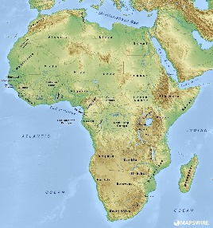  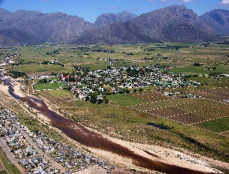
Continents: North America, South America, Europe, Antarctica, Asia, Oceania, Africa | 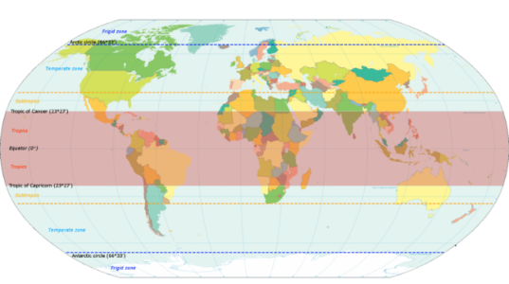 | Name and locate the world’s 7 continents and 5 oceans.
Atlantic Ocean
Pacific Ocean,
Indian Ocean,
Southern Ocean,
Arctic Ocean
Northern and Southern hemispheres | The Northern Hemisphere refers to the half of the planet that is north of the equator, while the Southern Hemisphere is all of the planet south of the equator. | Compare and contrast countries close to the equator and those further away.  Horwich Antarctica Namibia  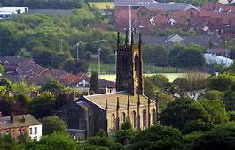  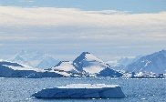  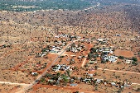
Equator | A line notionally drawn on the earth equidistant from the poles, dividing the earth into northern and southern hemispheres and constituting the parallel of latitude 0° | Locate the equator, tropic of cancer and tropic of Capricorn on a world map.
Tropic of Cancer | The Tropic of Cancer is the most northern latitude on the Earth where the sun can appear directly overhead. The Tropic of Capricorn is the most southern latitude on the Earth where the sun can appear directly overhead.
Tropic of Capricorn

