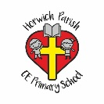 | Year Two Art – Street detectives (Drawing, colour)
Key vocabulary | Key knowledge | Key people
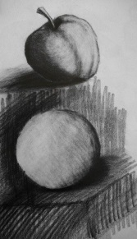 | Make as many tones of one colour as possible using primary colours and white. | Lowry
 | Sketch to make quick records of something.  Work out ideas through drawing. | Gerry Halpin
 | Talk simply about own work and that of other artists.
Drawing | A picture or diagram made with a pencil, pen or crayon rather than paint. | 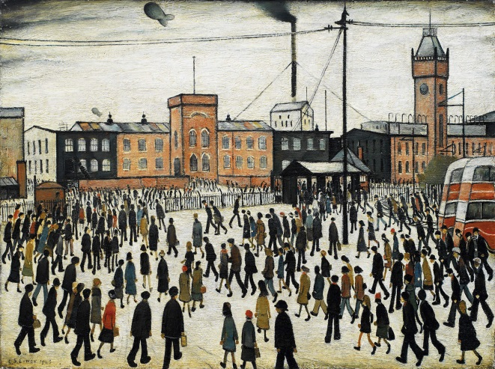
Shadowing | Shadow art is a unique form of sculptural art where the 2D shadows cast by a 3D sculpture are essential for the artistic effect.
Charcoal | Lighweight art material used for shadowing.
Pastels | Light weight art material used for colour.
Marks | a line, figure, or symbol made as an indication or record of something
Tone | Light and dark.
Line | An image that consists of distinct straight or curve lines placed against a background.
Painting | The action used to paint a picture.
https://gerryhalpin.co.uk/  https://www.bbc.co.uk/bitesize/clips/zc9jxnb |  | Key places
Local area of Horwich
North west
Manchester
Salford

 | Year Two Art- What a wonderful world (colour, printing, form and patterns)
Key vocabulary | Key knowledge | Key people
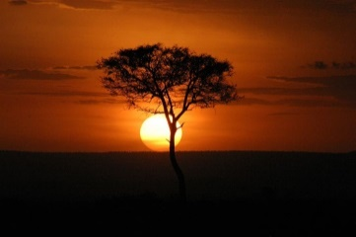 | Continue to draw a way of recording experiences and feelings. | Martin Bulinya  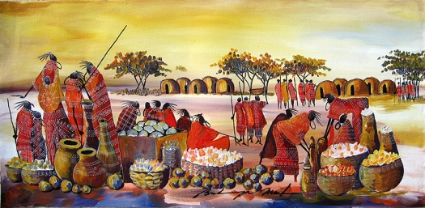
Darken colours without using black
Mix colours to match those of the natural world – colours that might have a less defined name.
 | Extends repeating patterns - overlapping, using two contrasting colours etc.
Still prints with a growing range of objects, including manmade and natural printing tools
Replicate patterns and textures in a 3-D form.
Use a range of decorative techniques: applied, impressed, painted, etc.

Use a range of tools for shaping, mark making, etc.
Drawing | A picture or diagram made with a pencil, pen or crayon rather than paint. | 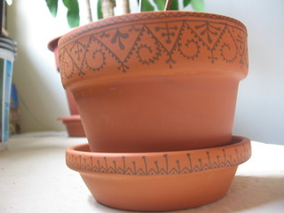
Sculpture | the action or art of making statues by carving or chiseling
Overlappping | Overlapping in art is the placement of objects over one another in order to create the illusion of depth.
Texture | The feel , appearance or consistency of a surface or substance.
Shape | A flat enclosed area of artwork created through lines, textures and colour.
Tone | Light and dark.
Line | An image that consists of distinct straight or curve lines placed against a background.
Painting | The action used to paint a picture.
Contrasting | A principle of art that refers to the arrangement of opposite elements
Patterns | Pattern is an underlying structure that organizes surfaces or structures in a consistent, regular manner
https://insideafricanart.com/martin-bulinya/  https://www.veniceclayartists.com/african-tribal-pottery-styles/ |  | Key places
Antartica
Arctic
Africa
Namibya
Kenya

 | Year Two Art- Wriggle and crawl (Drawing, Printing and pattern)
Key vocabulary | Key knowledge | Key people
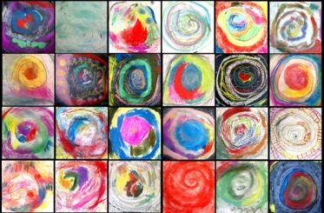 | Experiment by arranging, folding, repeating, overlapping, regular and irregular patterning. | Tracy McGuiness-Kelly
Use printmaking as a means of drawing
Create order, symmetry, irregularity

Continue to draw a way of recording experiences and feelings.
Sketch to make quick records of something.
Drawing | A picture or diagram made with a pencil, pen or crayon rather than paint. | 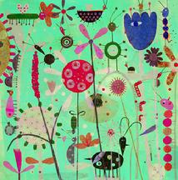
Printing | The product of
Irregular/Regular | Not even or balanced in shape or arrangement/ Even balance of shape or arrangement.
Pattern | a repeated decorative design
Shape | A flat enclosed area of artwork created through lines, textures and colour.
Tone | Light and dark.
Line | An image that consists of distinct straight or curve lines placed against a background.
Painting | The action used to paint a picture.
Symmetry | he quality of being made up of exactly similar parts facing each other or around an axis
Printing | A print that copies another work.
https://www.accessart.org.uk/i-am-accessart-tracy-mcguinness-kelly/  https://www.surfacecreative.com/tracy-mcguinness-kelly |  | Key places
Local area of Horwich
England
America

