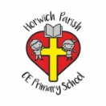 | Street detectives- (Make bridges based on local area. Use a range of materials and 3D maps.)  Year 2 DT
Key vocabulary | Explanation/ definition | KEY SKILLS  Work within a range of context  Plan by suggesting what to do next.  Talk about their design ideas and what they are making.  Begin to use the correct technical vocabulary for projects.  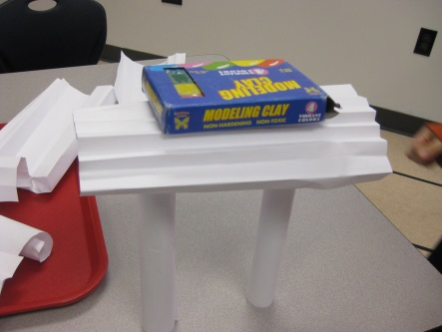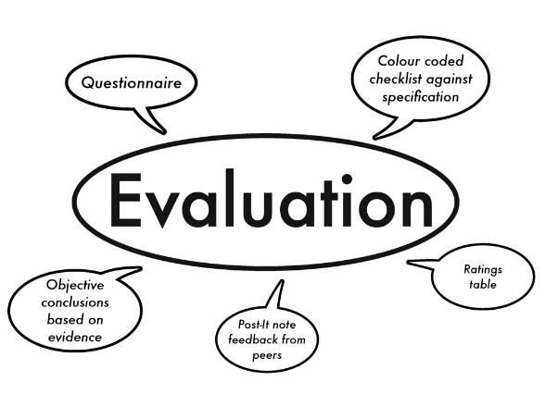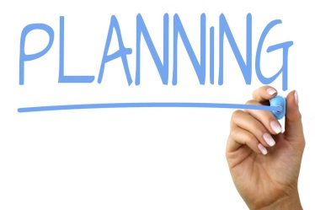
Structure | the arrangement of and relations between the parts or elements
Framework | an essential supporting structure of a building, vehicle, or object.
Design | a plan or drawing produced to show the look and function or workings of a building, garment, or other object before it is made.
Function | an activity that is natural to or the purpose of a person or thing
Purpose | the reason for which something is done
Evaluate | making a judgment
Base | the lowest part or edge of something
3D and 2D shapes | The name of common 2D and 3D shapes

Healthy eating (science link)
Year 2 DT
Key vocabulary | Explanation/ definition | Food hygiene 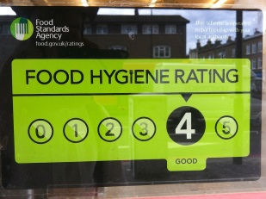  Recognise and group healthy foods  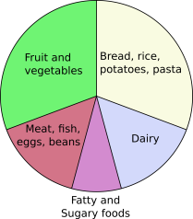 Design and explore
Healthy | indicating or promoting good health
Diet | the kinds of food that a person, animal, or community habitually eats.
Ingredients | any of the foods or substances that are combined to make a particular dish.
Taste | a person's liking for particular flavours.
Arranging | put (things) in a neat or required order.
Fruit/veg names | Names of common fruit and veg.
Design | a plan or drawing produced to show the look and function or workings of a building, garment, or other object before it is made.

Up, up and away (Mechanism – Create best flying machine.)
Year 2 DT
Key vocabulary | Explanation/ definition | Design and describe ideas  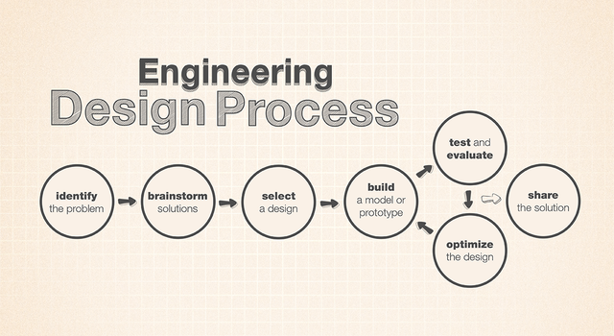  Select, use, measure and assemble a range of materials.  Understand the use of components  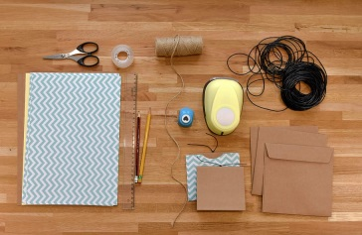 Explore and evaluate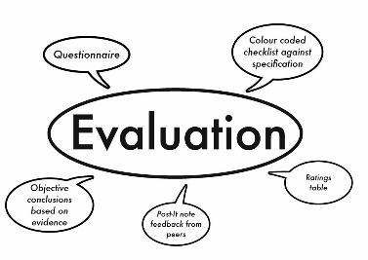
Axel | a rod or spindle (either fixed or rotating) passing through the centre of a wheel or group of wheels.
Chassis | the base frame of a car, carriage, or other wheeled vehicle
Shaping | give a particular shape or form to
Functional | designed to be practical and useful.
Joining | link; connect
Mechanism | a system of parts working together in a machine
Finishing | complete the manufacture or decoration of (an article)

Wriggle and crawl (Make a bug hotel to sell)
Year 2 DT
Key vocabulary | Explanation/ definition | Design, develop and communicate ideas  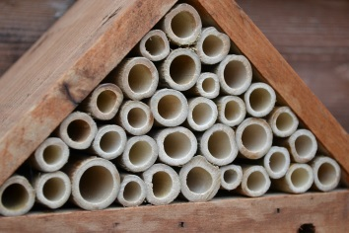  Select, assemble and join components  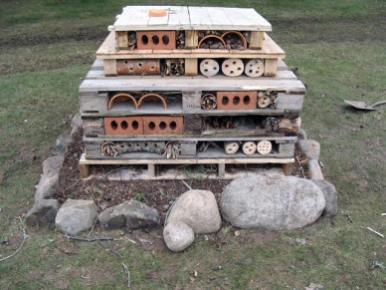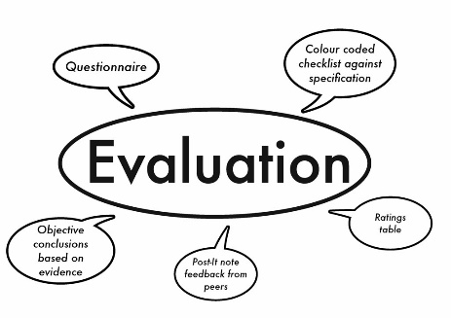  Explore and evaluate
Framework | an essential supporting structure of a building or object
Underneath | situated directly below
Edge | the outside limit of an object.
Surface | the outside part or uppermost layer of something
Product | a thing that is the result of an action or process
Function | an activity that is natural to or the purpose of a thing
Point | the tapered, sharp end of a tool, weapon, or other object.
Curved | having the form of a curve; bent

