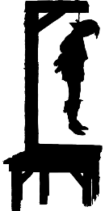
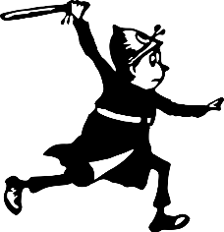
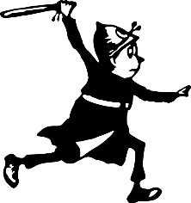
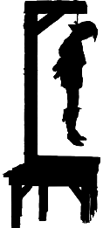
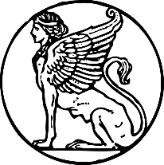
Year 5 Summer 1 Crime and Punishment
Timeline
43-410 | 480-1066 | 1066-1485 | 1485-1603 | 1603-1837 | 1837-1901 | 1901-now
Roman Britain | Anglo-Saxon Era | Middle Ages | Tudor Era | Stuart and  Georgian Era | Victorians | Modern Era
Key Vocabulary
Romans - Society was made up of the very rich but also of very poor slaves. This resulted in conflict and therefore crime. As slavery was legal, running away from an owner was considered a crime. Sellers would lie to customers and give them less (fraud) and large crowds gathering to spectate often resulted in riots. Roman laws were called ‘The Twelve Tables’. Major crimes would be punished by crucifixion, sent to fight in arenas or having molten lead poured down your throat! Vigiles were volunteers who patrolled the streets and Urban Cohorts would be sent to deal with emergencies.

deterrence | The action of discouraging crime through instilling doubt or a fear of consequences.
DNA profiling | From 1984, it identified someone from a crime scene through body fluids (e.g. skin, saliva, sweat etc).
gallows | A wooden structure with steps leading to a platform where criminals would be hung in front of an audience.  Anglo-Saxons - Anglo-Saxon Britain was not ruled by one person and the Anglo-Saxons were not united. They invaded as many different tribes and each took over different parts of Britain. The Anglo-Saxons didn't have prisons. People found guilty of crimes were either executed or punished with fines. If they ran away, they became 'outlaws' (outside the law), and anyone could hunt them down - unless they hid in a church. The fine for breaking into someone's home was five shillings (25p), paid to the home-owner. For minor crimes like stealing, a nose or a hand might be cut off.
highwayman | Dick Turpin was a famous English highwayman who rode a horse and stole from travellers.
justice | For someone to have fair treatment for their behaviour. Certain punishments are for certain deeds.
prevention | An attempt to reduce crime by deterring criminals to participate in such acts.  Tudors – Increasing populations, dissolution of the monasteries and gaps between rich and poor meant crime was very common. Public executions were huge events with families, food stalls and people queuing for hours to get a good spot. These included beheadings, hangings, burning, pressings and boiling alive! Begging without a licence would mean you would be whipped out of the town and theft resulted in having a limb chopped off (anything worth more than a shilling resulted in hanging). The idea was that severe punishments would put others off from committing crimes.
retribution | A punishment inflicted on someone as vengeance for a wrong or criminal act.
sin | An immoral act considered to be a against law or, more commonly, a religious belief.  Victorians – Anyone accused of a crime would be put in a ‘lock-up’ until they could see a magistrate who would decide whether they could be released or if they needed to be sentenced by a judge. Court rooms were created where victim and the accused could defend themselves and the death penalty became less common with a limited number of hangings. A police force was introduced in 1829. Public executions ended in 1868 and gaols (jails) were built to try to prevent people re-offending, although many were sent out to the Empire to serve sentences abroad.
stocks | The placing of boards around the ankles and wrists as a form of torture or humiliation.
witch trials | In the mid-1640s, terrifying witch hunts took place in the UK. Between 1500-1800, 50,00 men and women were executed for witchcraft across Europe.
Throughout the medieval period it was believed that to keep order, people had to be scared of the punishments. Trial by Ordeal included holding a red-hot iron bar (if it healed in 3 days they were innocent) or tying them up and throwing them in water (they floated if they were innocent). After 1215 Trial by Ordeal was replaced by Trial by Jury.
Modern Times – Modern society is seen as wealthier than in previous eras where more people are employed or can afford to live comfortably. There are still large gaps between the rich and poor in society and crime now ranges from physical (theft, assault, drink and drugs etc) to digital crime (e.g. fraud). Although the last public hanging took place in 1886, the last actual hanging was as late as August 13th 1964. Prisons now work hard to help rehabilitate people so that they do not re-offend and technological advances have meant catching criminals can be used by identifying fingerprints or even DNA.

