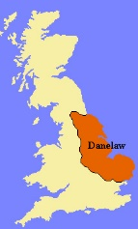
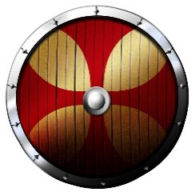
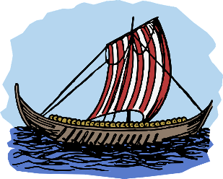
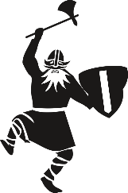
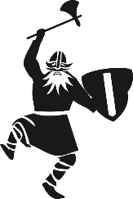
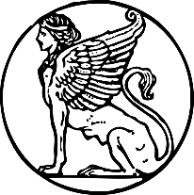
Lindisfarne
(England)
The Vikings
Danelaw
(England)
Timeline
700 | 789 | 793 | 865 | 866 | 876 | 886 | 1014 | 1066
The Viking Age begins | First recorded Viking attack | Viking raid on Lindisfarne | Viking army from Denmark invades England | Danes capture York (Jorvik) | Vikings from Denmark, Sweden and Norway settle permanently in England | King Alfred defeats the Vikings / Allows them to settle in East England | King Canute (Cnut) of Denmark King of England | Battle of Hastings / William I King of England
 | Key Vocabulary
Danelaw | An area of land ruled by the Vikings where they settled from York down to the east of England.
drinking horn | Made from the horns of goats and cattle, these were used when drinking water, milk or mead.
helmet | Helmets were made from iron with a bowl and nose guard and leather within. They did not have horns!
jewellery | Using a rage of materials from gold to animal bones they made rings, brooches, necklaces and bracelets.
long boat | Long, narrow ships that could travel fast, in shallow waters for incredibly long distances.
longhouse | Made of wattle and daub, wood or stone with an open fire in the centre of one single room.
loom | Viking women would spin wool or flax which was then woven into cloth using a wooden framed loom.
runes | The alphabet (Futhark) was made up of 24 characters (runes) making a sound, word or god.
shield | Wooden, circular and painted (often red and white). Often their only defence (armour was expensive).
Valhalla | Brave warriors were believed to go to Valhalla in the afterlife – a great hall, feasting alongside Odin.
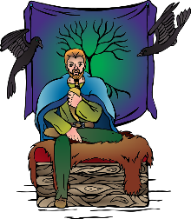

Invaders
The Vikings wanted new land because the places where they came from in Scandinavia (Norway, Sweden and Denmark). It was hard to grow crops, which meant there was a food shortage as the population got bigger. Britain and Europe had plenty of good farmland, so the Vikings tried to claim some of that land for themselves.

Religion
The Vikings believed in many different gods and they thought making sacrifices to the gods kept them all happy. They also told stories about the gods, called Norse mythology. Each god was in charge of something different such as war, travel or home.
Odin - the king of gods / the god of war
Thor - the god of thunder
Freyja – the god of love and war
Loki – half god and half fire spirit causing
trouble for the other gods

Clothes
Mostly made from wool or linen. They used dyes made from plants and minerals to make red, green, brown, yellow and blue, so their clothes were very colourful.

General Knowledge

Eric Bloodaxe (885-954)
Eric Bloodaxe was king of the Viking kingdom of Jorvik between 947-948 and 952-954. Jorvik was a large Viking kingdom around York. He was the last King of York who was driven out in 954. The Vikings in England then agreed to be ruled by the king of England rather than having their own king.

Leif Erikson (c.970-1020)
Leif Erikson was a famous Viking explorer from Iceland who sailed all the way to North America.

King Canute (990-1035)
Canute was the first Viking king of England, ruling from 1016-1035. He won a battle against Edmund II that divided their kingdoms, but when Edmund died Canute ruled both kingdoms. His sons, Harold Harefoot and then Hardicanute, ruled until 1042.

Harald Hardrada (c.1015-1066)
Harald Hardrada was the king of Norway. He led Viking armies into England but was defeated at the Battle of Stamford Bridge in York by King Harold II.

Some of the names of our towns and villages have a little bit of Norse language in them. Do you recognise any names with endings like these: ‘-by’, as in Corby or Whitby, means ‘farm’ or ‘town’‘-thorpe’, as in Scunthorpe, means ‘village’
‘-thorpe’, as in Scunthorpe, means ‘village’
