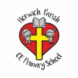 | PSHCE- keeping safe and staying healthy
Key vocabulary | Explanation/ definition | Key knowledge
nicotine | a toxic colourless or yellowish oily liquid which is the main ingredient of tobacco. It acts as a stimulant in small doses, but in larger amounts blocks the action of nerves. | Be able to predict and assess the level of risk in different fun situations Be able to understand the risks associated with alcohol  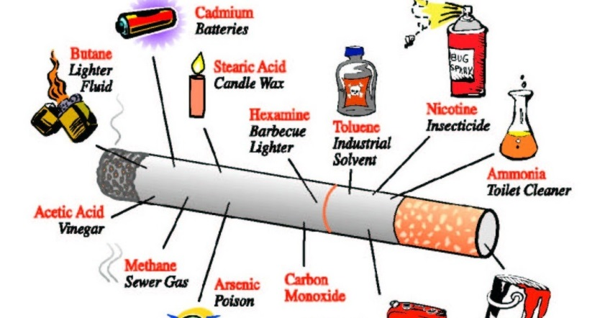  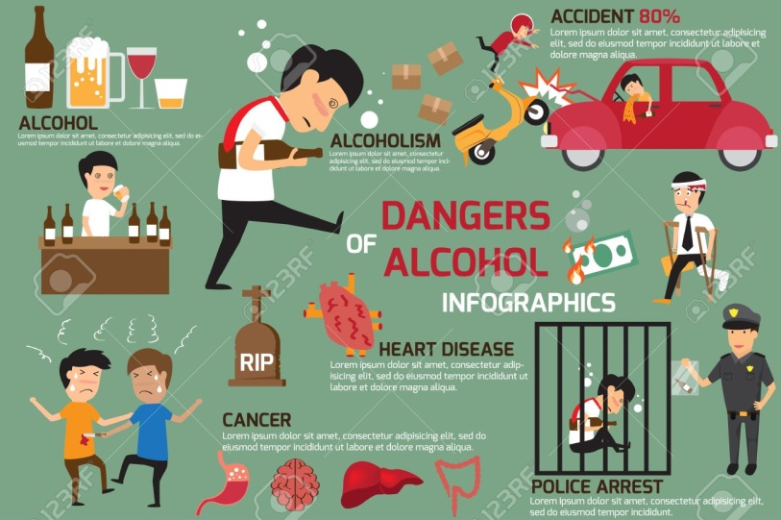
alcohol | a colourless flammable liquid which is produced by the natural fermentation of sugars and is the intoxicating part of wine, beer, spirits, and other drinks.
Vital organs | An organ( heart, lungs etc) of the body which performs a sufficiently important function that damage to the organ can cause death.
Blood pressure | the pressure of the blood in the circulatory system. It is closely related to the force and rate of the heartbeat.
addictive | causing a strong and harmful need to regularly have or do something. : very enjoyable in a way that makes you want to do or have something again
Balanced diet | a diet that contains adequate amounts of all the necessary nutrients required for healthy growth and activity
intoxicating | (of alcoholic drink or a drug) which can cause someone to lose control of their behaviour

