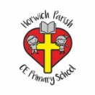 | RE Autumn term 1 Year Four  God, David and the Psalms
Key vocabulary | Explanation/ definition | Key Knowledge
Samuel | Samuel was around three years old when he was sent by his parents to live at the tabernacle to learn how to become a priest.  He had at least four important jobs:  - High priest  - Prophet (he was the first of the major prophets)  - Warrior/leader (he led the Israelites in a successful battle against the Philistines)  - Judge (judges were government officials e.g. governors) | - David is a key figure in God’s plan for his people.  - Some Christians have had to endure great struggles and persevere in difficult circumstances to keep faith in God and follow his way.  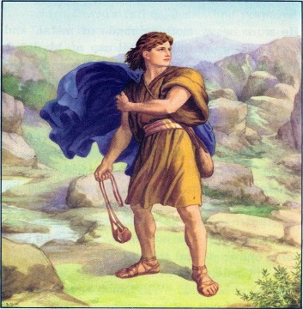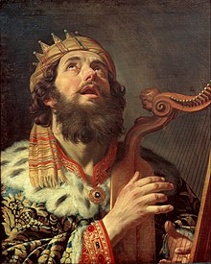  David the shepherd boy defeating David the king of Israel  Goliath
David | Person from the Old Testament. As a young boy shepherd, defeated Goliath and eventually became the king of Israel.
Johnathan | Eldest son of King Saul and friend of David.
Saul | He was the first King of Israel.
Goliath | A Philistine warrior from the Old Testament.
Inspiration | The process of being mentally stimulated to do or feel something, especially to do something creative.
Psalm | Sacred song or hymn used in worship.
Key skills
By the end of this unit, pupils are expected to be able to:
- Retell stories about David
- Recognise their own values and the values of others.
- Connect Christian values and beliefs to events and teaching in the Bible.
- Ask important and relevant questions.
- Show that they understand how the imagery of the Psalms reveals Christian beliefs about the nature of God.

