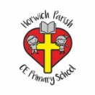 | RE Summer term 1 Year Four  Are all churches the same? Places of worship/how people worship in different faiths.
Key vocabulary | Explanation/ definition | Key Knowledge
Church | a building for Christian religious activities | - Not all church buildings are the same but have similar features according to denomination.  - Peter and the disciples ‘built’ the church after the events of Pentecost.  - Christianity is a world-wide multi-cultural faith.  - The Bible gives guidance to the church about behaviour and attitudes and what that guidance is.  - People of other faiths have different places of worship, the names of those buildings, key features and the worship that takes place there.  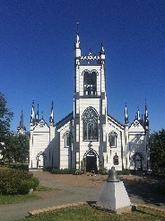  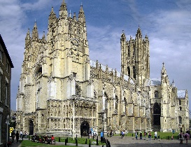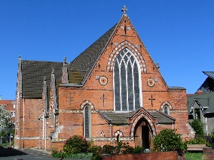  Different Anglican churches  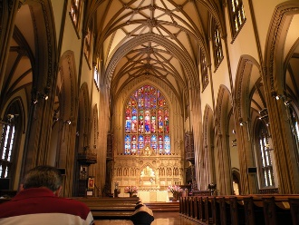  Inside …  …an Anglican church  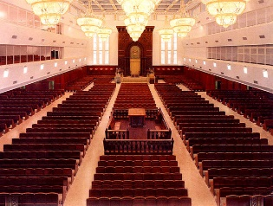  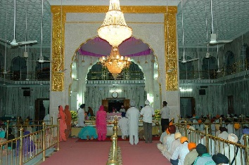  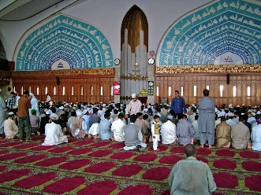  … a synagogue … a mosque … a gurdwara
Chapel | A small church or a part of a church which has its own altar and which is used for private prayer
Cathedral | a large important Christian church which has a bishop in charge of it.
Sacrament | an important religious ceremony in the Christian Church, such as baptism or communion
clergy | the religious leaders whose job is serving the needs of their religion and its members ; priests, ministers, rabbis
bishop | a clergyman of high rank in the Roman Catholic, Anglican, and Orthodox churches, who supervises a number of local churches or a diocese
vicar | an Anglican priest who is in charge of a church and the area it is in, which is called a parish.
Curate | a member of the clergy employed to assist a rector or vicar
Priest | a person who has been trained to perform religious duties in some Christian churches
minister | a person authorised to conduct religious worship
denomination | a religious group that has slightly different beliefs from other groups that share the same religion
synagogue | a building where Jewish people meet to worship or to study their religion.
Rabbi | a Jewish religious leader, usually one who is in charge of a synagogue, one who is qualified to teach Judaism, or one who is an expert on Jewish law.
Mosque | - a place of worship for Muslims
minaret tower | a tall, thin tower on or near a mosque from which Muslims are called to pray
Imam | the person who leads prayers in a mosque.
Temple | a building used for the worship of a god or gods, especially in the Buddhist, Jewish, Mormon, and Hindu religions, and in ancient Greek and Roman times
Gurdwara | A Sikh temple used for worship
Key skills
By the end of this unit, pupils are expected to be able to:

use religious vocabulary to name features of the church building, talk about their significance and link to the Bible.

identify similarities and differences between churches and denominations worldwide.

ask good questions about the similarities and differences between different denominational practices.

make links between values and beliefs and behaviour.

talk knowledgeably about other places of worship, the features of the building and the worship that takes place there.

