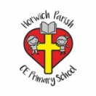 | RE Summer term 1 Year Two  Why is the church a special place for Christians? Where do other faiths worship?
Key vocabulary | Explanation/ definition | Key Knowledge
Church | a building for Christian religious activities | - The church is a special place where Christians meet to worship and pray. It is also the body of people not just the building.  - For Christians, the church is a holy blessed space.  - Moses and the people of God built the Tabernacle (tent of meeting) to house the ark of the covenant.  - People of other faiths have special holy places of worship, what these buildings are called, their key features, and the worship that takes place there.  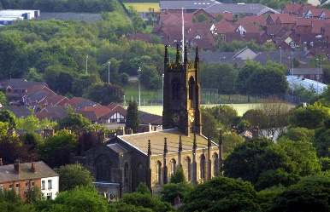  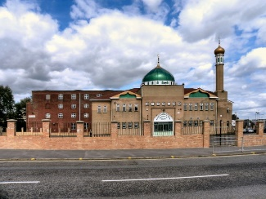  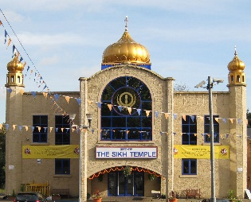  Holy Trinity Church A Mosque A Gurdwara  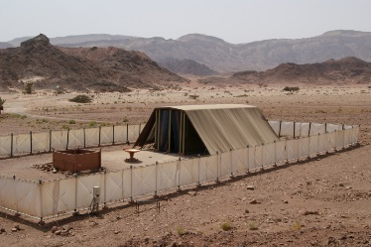  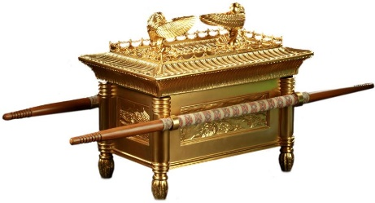  Tabernacle Ark of the Covenant
vicar | A vicar is an Anglican priest who is in charge of a church and the area it is in, which is called a parish.
minister | a person authorised to conduct religious worship
pews | A pew is a long wooden seat with a back, which people sit on in church
font | a large bowl for baptismal water, usually mounted on a pedestal
altar | a type of table used in ceremonies in a Christian church or in other religious buildings
stained glass | glass that has been coloured and cut into various shapes to form pictures or patterns, used especially in church windows:
worship | to show respect and love for God or for a god especially by praying, having religious services, etc.
Holy | If you describe something as holy, you mean that it is considered to be special because it is connected with God or a particular religion.
sacred | considered to be holy and deserving respect, especially because of a connection with a god:
Mosque | - A mosque is a place of worship for Muslims
minaret tower | a tall, thin tower on or near a mosque from which Muslims are called to pray
Temple | A temple is a building used for the worship of a god or gods, especially in the Buddhist, Jewish, Mormon, and Hindu religions, and in ancient Greek and Roman times
Tabernacle | For the Jews in ancient times, a tabernacle was a type of tent moved from place to place and used for worship.
Ark of the covenant | in the Bible, a wooden box that contained the writings of Jewish law, and that represented to the people of Israel the idea of God being present and leading them
Gurdwara | a temple and place of worship for Sikhs
Key skills
By the end of this unit, pupils are expected to be able to:

Ask good questions that reveal understanding about the church and what happens there.

Connect the features of the church to Bible Stories.

Use religious vocabulary to name and describe the features of a church building and other places of worship.

Describe a few similarities and differences between places of worship.

