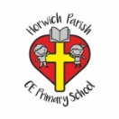 | RE Autumn term 1/2 Year Two  The Bible. Why is it such a special book?
Key vocabulary | Explanation/ definition | Key Knowledge
Bible | The collection of sacred writings of the Christian religion, comprising the Old and New Testaments. | - The Bible is the Christian holy book.  - The Bible is made up of a library of books.  - The Bible is in two sections the Old Testament and the New Testament.  - Owning a Bible is very important to Christians.  - The Bible contains God’s big story from the beginning through to the kingdom of God.  - People of different faiths have different holy books and there are some similarities and differences between these books and the Bible.  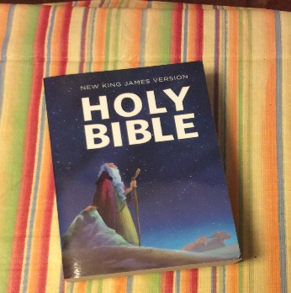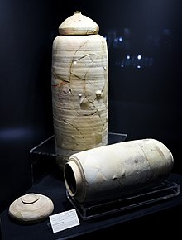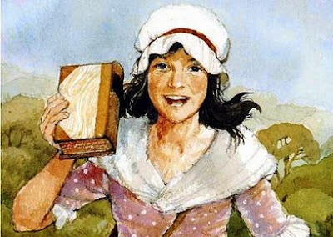
Old Testament | The first of the two main parts of the Christian Bible (written before the birth of Jesus).
New Testament | The collection of the books of the Bible that were produced by the early Christian church.
Holy | Relating to God.
Gospel | Any of the first four books of the New Testament.
Word of God | Something that God has said
Mary Jones | Was a Welsh girl who, at fifteen years old walked twenty-six miles barefoot across the countryside to buy a copy of the Welsh Bible from Thomas Charles because she did not have one. Her story inspired the founding of the British and Foreign Bible society.
Dead Sea Scrolls | A collection of Jewish manuscripts discovered in pottery storage jars in caves near Qumran between 1947 and 1956. The scrolls include texts of may books of the Old Testament.
Key skills
By the end of this unit, pupils are expected to be able to:
- Talk about the Bible and why it is Holy.
- Talk about why the clergy think it is Holy.
- Talk about why owning a Bible is very important to Christians worldwide.
- Make links between the books of the Bible and God’s big story.
- Reflect on the story of Mary Jones and consider ways in which they can make a difference.
- Name and talk about the books from faiths other than Christianity.

