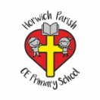 | RE Spring term 1 Year One  My world, Jesus’ world
Key vocabulary | Explanation/ definition | Key Knowledge
Jesus | The son of God. | - Jesus lived a long time ago in a world very different to ours.  - Christians believe that Jesus is the son of God.  - Christians believe that Jesus understands what it is like to live an everyday life as a human.  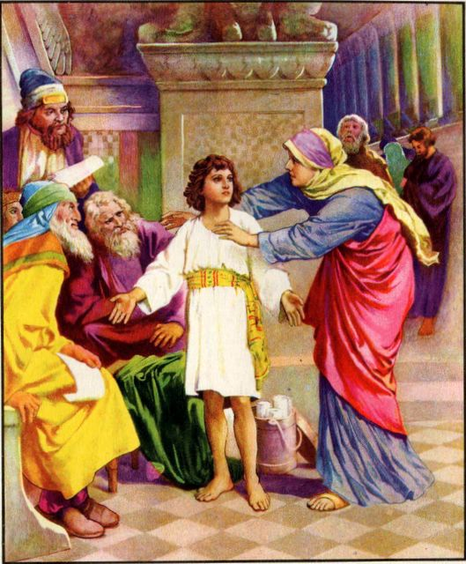  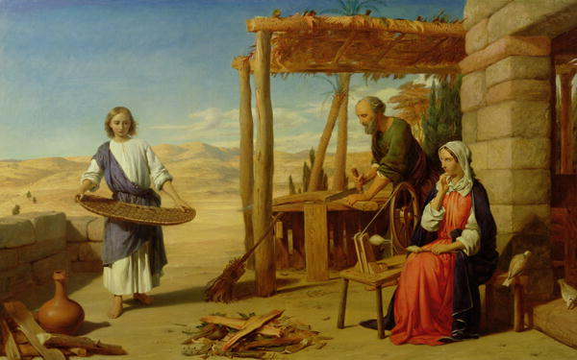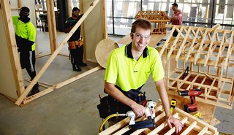  Jesus helping Joseph Modern day carpentry
Jerusalem | A holy city for Jews, Christian’s and Muslims; the ancient kingdom of Judah and the modern state of Israel. The name means city of peace.
Nazareth | A town in lower Galilee (in present day northern Israel) and the bible tells us the home of Mary, Joseph and a young Jesus.
Key skills
By the end of this unit, pupils are expected to be able to:
- Talk about the differences between my world and Jesus’ world.
- Use a bible story to show the differences and similarities between my world and Jesus’ world.
- Ask good questions and talk about my experiences.

