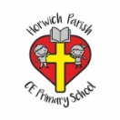 | RE Summer term 2 Year One  God and creation
Key vocabulary | Explanation/ definition | Key Knowledge
God | Who Christians believe is the supreme being, creator and ruler of the universe. | - Christians believe that God created the world.  - The creation stories are at the very beginning of the Bible and be able to recall details briefly.  - Christians believe that people should be taking care of our world.  - Christians believe that in creation we can see the power and wonder of God.  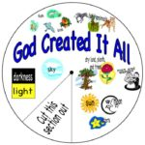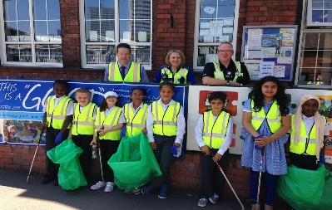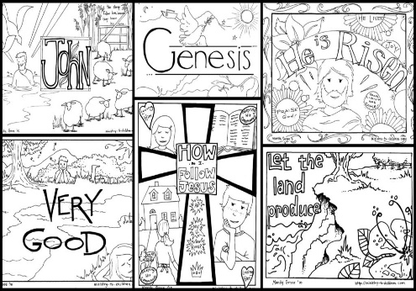
Creation | The act of producing or causing something to exist; the act of creating.  The Creation: the original bringing into existence of the universe by God.
Genesis | The first book of the Old Testament which starts with The Creation story.
Pollution | Harmful or poisonous substances introduced into an environment.
World | The planet Earth.
Environment | External conditions or surroundings in which people, animals, or plants live.
Psalm | A sacred song.
Hymns | A type of song, usually religious, specifically written for the purpose of adoration or prayer.
Key skills
By the end of this unit, pupils are expected to be able to:
- Talk about what they find amazing, interesting, or puzzling in creation.
- Understand that they are creative beings and enjoy their creative skills.

