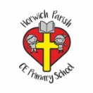 | RE Spring term 2 Year One  Easter Celebrating New Life and New Beginnings
Key vocabulary | Explanation/ definition | Key Knowledge
Good Friday | The Friday before Easter Sunday on which the crucifixion of Christ is commemorated in the Christian church. | - The events of Palm Sunday, Good Friday and Easter Day are at the core of Christian beliefs.  - Christians believe that Easter is a new beginning.  - Christians believe that Jesus died and rose back to life again.  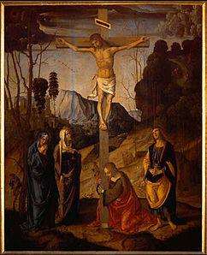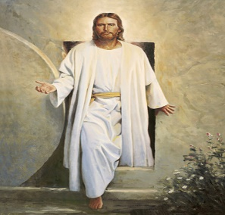
Easter Sunday | The celebration of Jesus Christ rising from the dead (his resurrection) after his crucifixion.
Jesus | The son of God.
New life | The start of something new.
Holy Week | The week before Easter starting on Palm Sunday.
Disciples | The twelve special friends of Jesus.
Mary | The mother of Jesus.
Resurrection | Rising from the dead.
Garden | A piece of land for growing flowers, fruit and vegetables.
Tomb | A grave for one or more corpses.
Key skills
By the end of this unit, pupils are expected to be able to:
- Recall events of the Easter story.
- Reflect on the awe and wonder of new life and changes in nature.
- Talk about their own experiences of Easter and springtime.
- Retell the events of the Easter story.

