 | PSHCE- Keeping/staying safe
Key vocabulary | Explanation/ definition | Key knowledge
opinion | view or judgement formed about something, not necessarily based on fact or knowledge. | Warning signs and water Dangers of water  Cycle safety/ peer pressure/ water safety  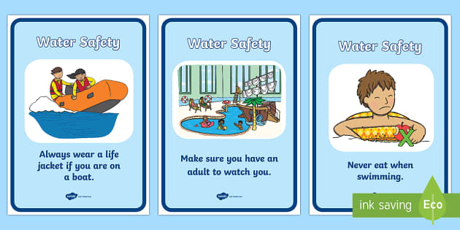  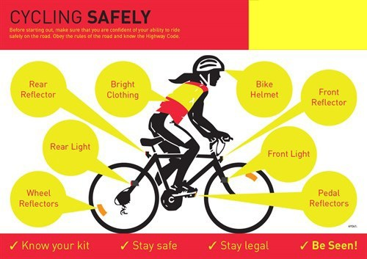
Strategies | a plan of action designed to achieve a long-term or overall aim or plan
Peer pressure | a feeling that one must do the same things as other people of one's age and friendship group in order to be liked or respected by them.
consequences | a result or effect, typically one that is unwelcome or unpleasant.
fact | A fact is something that has become known as true.

 | PSHCE- keeping safe and staying healthy
Key vocabulary | Explanation/ definition | Key knowledge
nicotine | a toxic colourless or yellowish oily liquid which is the main ingredient of tobacco. It acts as a stimulant in small doses, but in larger amounts blocks the action of nerves. | Be able to predict and assess the level of risk in different fun situations Be able to understand the risks associated with alcohol  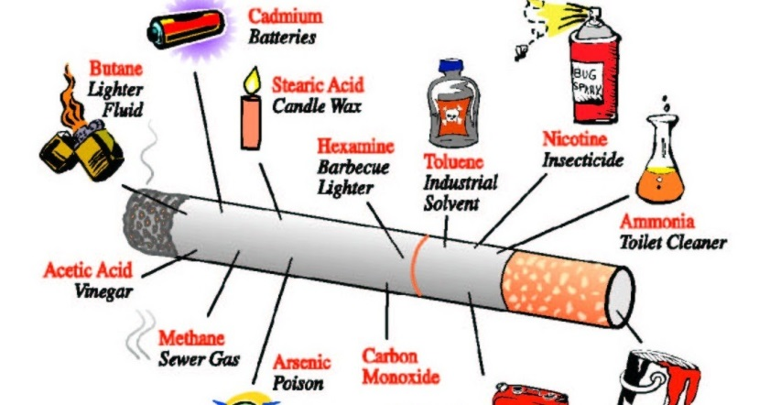  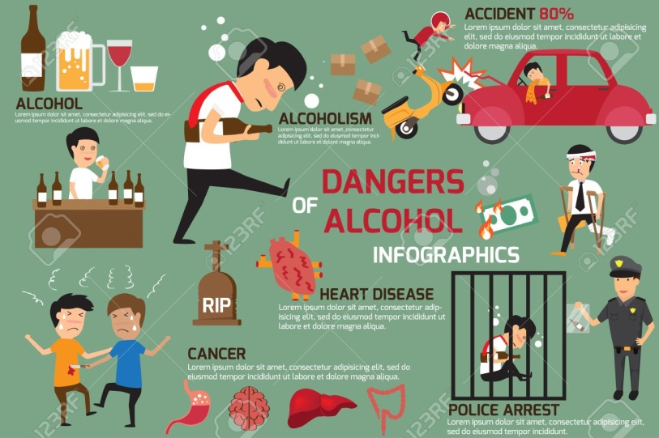
alcohol | a colourless flammable liquid which is produced by the natural fermentation of sugars and is the intoxicating part of wine, beer, spirits, and other drinks.
Vital organs | An organ( heart, lungs etc) of the body which performs a sufficiently important function that damage to the organ can cause death.
Blood pressure | the pressure of the blood in the circulatory system. It is closely related to the force and rate of the heartbeat.
addictive | causing a strong and harmful need to regularly have or do something. : very enjoyable in a way that makes you want to do or have something again
Balanced diet | a diet that contains adequate amounts of all the necessary nutrients required for healthy growth and activity
intoxicating | (of alcoholic drink or a drug) which can cause someone to lose control of their behaviour

 | PSHCE- being responsible
Key vocabulary | Explanation/ definition | Key knowledge
Responsible | being able to consciously make decisions, conduct behaviors that seek to improve oneself and/or help others. Most importantly, a responsible person accepts the consequences of his or her own actions and decision. | Understand the importance of not stealing Why is it important to be considerate and maintain a positive reputation? Understand we should not take people’s possessions without permission  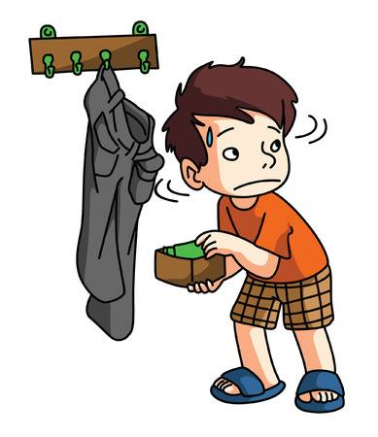
punctual | Punctual" means "on time". It is also acceptable that punctual can also, be related to be talking about grammar, means "to be accurate
consent | permission for something to happen or agreement to do something
honest | truthful and sincere.
Circumstances | A circumstance is the condition in which something happens.
irresponsible | (of a person, attitude, or action) not showing a proper sense of responsibility.

 | PSHCE- feelings and emotions
Key vocabulary | Explanation/ definition | Key knowledge
Emotions | a strong feeling deriving from one's circumstances, mood, or relationships with others. | Be able to recognise thought, feelings and emotions and understand the differences between those which make us feel good and those that feel not so good. Understand how we can recognise worry and support self or others who may be worried  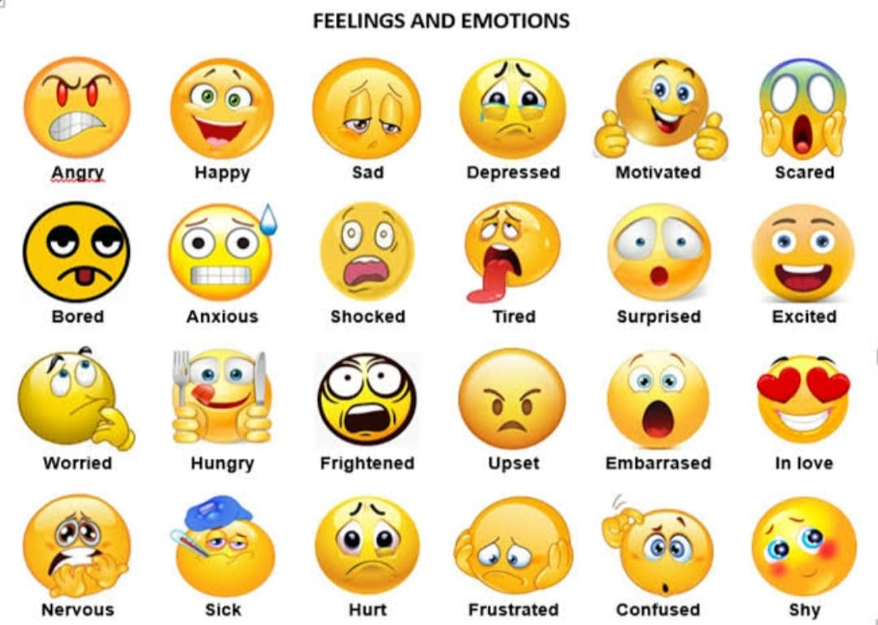
Feelings | A feeling is an emotion, such as anger or happiness.
troubled | to describe someone who is upset or distressed, or a situation that is difficult.
hostility | Hostile behaviour or being unfriendliness
displeasure | a feeling of annoyance or disapproval
potential | Potential is defined as the possibility of becoming something

 | PSHCE- computer safety
Key vocabulary | Explanation/ definition | Key knowledge
offensive | causing someone to feel resentful, upset, or annoyed | Know and understand the potential dangers of talking to people online Understand that fake online profiles exist, and people not always be who they say they area. Staying safe online  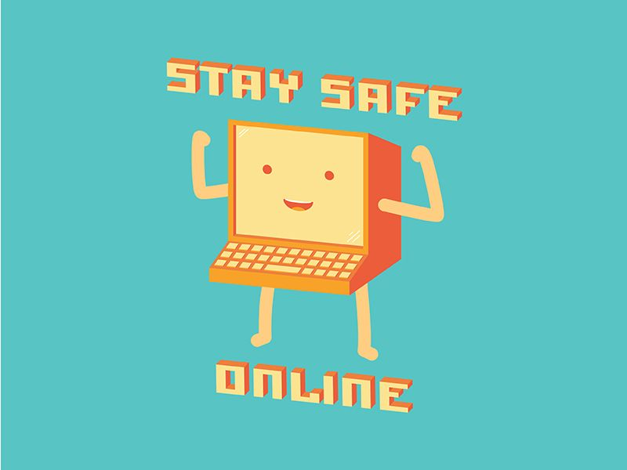
Application(app) | a software program that's designed to perform a specific function directly for the user.
insulting | disrespectful or scornful.
online | controlled by or connected to a computer
virus | is a malicious software program loaded onto a user's computer without the user's knowledge and performs malicious actions.
consent | permission for something to happen or agreement to do something.

