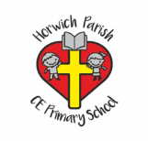 Art Knowledge Organiser Year 6 Form Tour De France Project
Skills | vocabulary | Artists
Form  Shape, form, model and join with confidence. (yr5)  Makes imaginative use of the knowledge they have acquired of tools, techniques and materials to express own ideas and feelings  Texture  Develops experience in embellishing, pooling together experiences in texture to complete a piece – applique, drawing, sticking, cutting, paint, weaving, layering etc. | Hook and eye: a small metal hook and loop used together as a fastener  Looping: form (something) into a loop or loops; encircle  Braid: interweaving three or more strands of rope-like band formed by plaiting or weaving together several strands.  Relief sculpture: created on a flat surface. The back of the sculpture is not meant to be seen.  All around sculpture:3D sculpture meant to be seen at all angles  Kinetic or mobile sculpture: contains moveable parts in the design | Alexander Calder (July 22, 1898 – November 11, 1976)  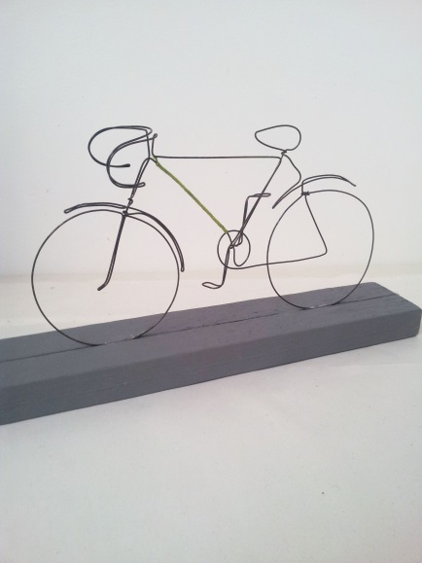  Alexander Calder was an American artist best known for his invention of the mobile and his wire sculptures  Born into a family of artists, Calder's work first gained attention in Paris in the 1920s and was soon championed by the Museum of Modern Art in New York.

