Wonder Portraits – Spring Term 1
Year 5 Art
Key vocabulary | Explanation/ definition | Key knowledge
cubism | An early 20th-century style and movement in art, especially painting, in which perspective with a single viewpoint was abandoned and use was made of simple geometric shapes, interlocking planes, and, later, collage. | Pablo Picasso was born in Malaga, Spain in 1881. When he was baptized, his name was 23 words long!  Picasso co-founded the Cubist movement. Cubism was a new way of painting, in which artists would paint a person or object from different angles using geometric shapes.  Picasso died in France in 1973. Several of his paintings are amongst the most expensive in the world. More of his paintings have been stolen than any other artist’s.
abstract | 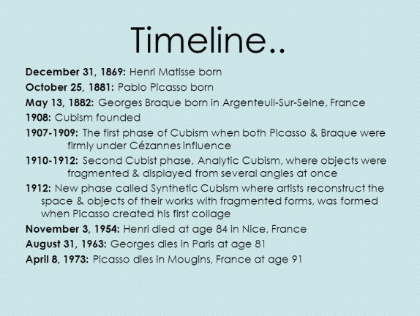  Painting images and objects in a simplified way so that they  remain recognisable but certain aspects are emphasised
portrait | A painting, drawing or photograph, especially one depicting  the face or head and shoulders
contemporary | The art of today
monochrome | A work of art completed in one colour
