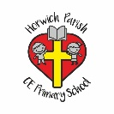 | Year One Art – Moon Zoom Planets and Aliens.
Key vocabulary | Key knowledge | Key people
 | To use a range of materials creatively to design and make products. Paper Mache planets and to sculpture the planet. | Neil Armstrong. - First man on the moon.
 | To use drawing, painting to develop and share their ideas, experiences and imagination. | Aliens – Made up imaginary character.
Drawing | A picture or diagram made with a pencil, pen or crayon rather than paint. | 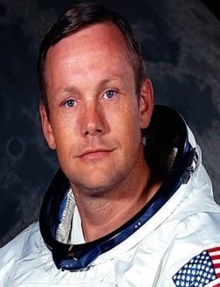  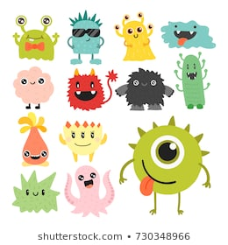
Printing | The product of
Sculpture | 2 or 3 dimensional representations by casting clay or plaster.
Texture | The feel , appearance or consistency of a surface or substance.
Shape | A flat enclosed area of artwork created through lines, textures and colour.
Tone | Light and dark.
Line | An image that consists of distinct straight or curve lines placed against a background.
Painting | The action used to paint a picure.
Form | 3 dimensional of objects ( same as shape but 3 d)
 |  | Key places
 |  | Sun, moon, mercury, Venus, Mars, Earth, Jupiter, Saturn Uranus Neptune, Space, stars. Rockets.

 | Year One Art – Into the woods, Bog baby and Lord Leverhulme.
Key vocabulary | Key knowledge | Key people
 | To use drawing, painting and sculpture to develop and share their ideas, experiences and imagination. | Bog Baby
 | To develop a wide range of art and design techniques in using colour, pattern, texture, line, shape, form and space. | Lord Leverhulme.
Drawing | A picture or diagram made with a pencil, pen or crayon rather than paint. | 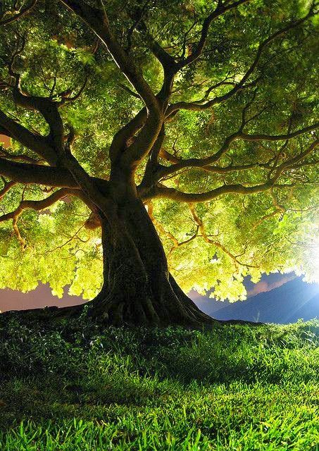
Printing | The product of
Sculpture | 2 or 3 dimensional representations by casting clay or plaster.
Texture | The feel , appearance or consistency of a surface or substance.
Shape | A flat enclosed area of artwork created through lines, textures and colour.
Tone | Light and dark.
Line | An image that consists of distinct straight or curve lines placed against a background.
Painting | The action used to paint a picture.
Form | 3 dimensional of objects ( same as shape but 3 d)
 |  | Key places
 |  | Woods, trees, plants, leaves, sky, rocks, stones, Bridge, branches, sticks, mud, grass, bog, water, river, stream.

 | Year One Art – Seasides and lighthouses in the style of George Seurat.
Key vocabulary | Key knowledge | Key people
 | To look at the work of a range of Artists. | George Seurat. – Famous artist who’s paintings where formed in the style of dots.
 | To describe the differences and similarities between different practices and disciplines within the art work. | Grace Darling- Famous heroine who lived in a lighthouse.
 | To make links to their own work and that of George Seurat.
Drawing | A picture or diagram made with a pencil, pen or crayon rather than paint. | 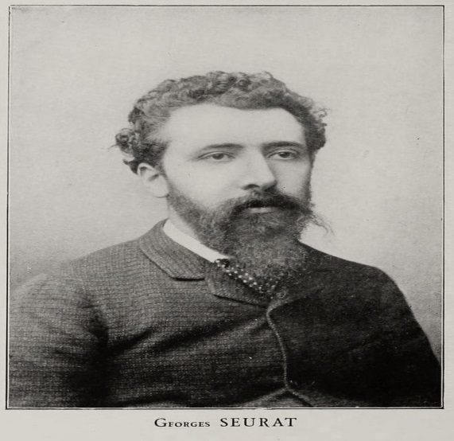
Printing | The product of
Sculpture | 2 or 3 dimensional representations by casting clay or plaster.
Texture | The feel , appearance or consistency of a surface or substance.
Shape | A flat enclosed area of artwork created through lines, textures and colour.
Tone | Light and dark.
Line | An image that consists of distinct straight or curve lines placed against a background.
Painting | The action used to paint a picure.
Form | 3 dimensional of objects ( same as shape but 3 d)
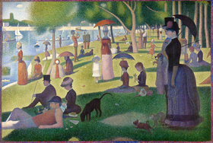 |  | Key places
 |  | Land, sea, lighthouses, cliffs, sand, seasides, lakes, mountains, sky.

