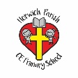 | Music Year Two – Acting as a Musician. Singing, playing and Performing.
Key vocabulary | Explanation/ definition | Key skills and knowledge
Pitch | How high or low a sound is. | - Sing songs with a wider pitch range (C-C) showing a sense of melodic shape.  - Sing lah-soh-me songs with accurate pitch matching.  - Explore using the voice expressively and creatively.  - Copy a simple rhythm on a percussion instrument.  - Beat the pulse of a piece of music, using body and using a percussion instrument.  - Begin to identify the difference between pulse and rhythm.  - Internalise a steady pulse e.g. use the ‘thinking voice’ to ‘sing’ short extracts in own head.  - Create crescendo (getting louder) and diminuendo (getting quieter) vocally and instrumentally.  - Create accelerando (getting faster) and rallentando (getting slower) vocally and instrumentally.  - Experience singing songs with different structures e.g. verse/ chorus.  - Add simple accompaniments to songs using tuned and untuned percussion instruments e.g. drones or keeping pulse on a drum.  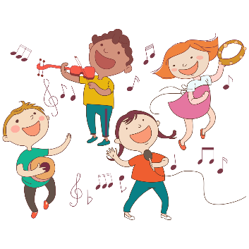  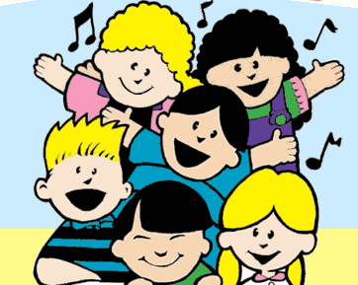
Pulse | The underlying steady beat of music. (This is what we may tap our foot or clap along with.)
Rhythm | Combinations of long and short sounds that convey movement.
Melody | Another name for a tune.
Dynamics | How loud or quiet the music is.
Tempo | An Italian word used to describe how fast/slow the music goes.
perform | Sing and play instruments.
performance | an act of performing a song or piece of music
audience | the group of people together in one place to listen to a song or a piece of music

 | Music Year Two – Thinking as a Musician - Transcribing
Key vocabulary | Explanation/ definition | Key skills and knowledge
Pitch | How high or low a sound is. | • Use a simple graphic score for performing or as a stimulus for composition.  • Begin to recognise the link between shape and pitch in graphic notations.  • Experience using Music Technology to capture, change and combine sounds.  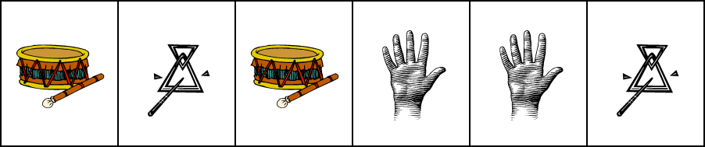  Drum Triangle
Pulse | The underlying steady beat of music. (This is what we may tap our foot or clap along with.)
Rhythm | Combinations of long and short sounds that convey movement.
Melody | Another name for a tune.
Dynamics | How loud or quiet the music is.
Tempo | An Italian word used to describe how fast/slow the music goes.
perform | Sing and play instruments.
performance | an act of performing a song or piece of music
audience | the group of people together in one place to listen to a song or a piece of music
notation | the link between sound and symbol.
graphic score | a way in which we can write music without having to write musical notes. You can use shapes and symbols in your graphic score to represent an instrument.
compose | To create and develop musical ideas and ‘fixing’ them.
improvise | To make up a tune and play it on the spot. There is an assumption that it can never be recreated.

 | Music Year Two – Acting as a Musician. Exploring and Composing.
Key vocabulary | Explanation/ definition | Key skills and knowledge
Pitch | How high or low a sound is. | - Create music as a response to a stimulus e.g. a rocket launching, a rainstorm, a rockpool etc. choosing and using appropriate instruments to create an idea.  - Experiment with, create, select, combine and sequence sounds using the inter-related dimensions.  - Clap a simple rhythmic pattern for others to copy.  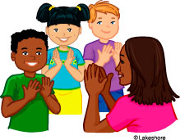  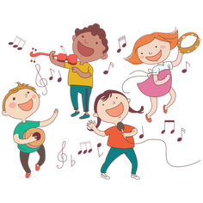
Pulse | The underlying steady beat of music. (This is what we may tap our foot or clap along with.)
Rhythm | Combinations of long and short sounds that convey movement.
Melody | Another name for a tune.
Dynamics | How loud or quiet the music is.
Tempo | An Italian word used to describe how fast/slow the music goes.
perform | Sing and play instruments.
performance | an act of performing a song or piece of music
audience | the group of people together in one place to listen to a song or a piece of music
notation | the link between sound and symbol.
graphic score | a way in which we can write music without having to write musical notes. You can use shapes and symbols in your graphic score to represent an instrument.
compose | To create and develop musical ideas and ‘fixing’ them.
improvise | To make up a tune and play it on the spot. There is an assumption that it can never be recreated.

 | Music Year Two – Thinking as a Musician. Describing.
Key vocabulary | Explanation/ definition | Key skills and knowledge
Pitch | How high or low a sound is. | - Identify patterns of one and two sounds per beat and use rhythm names (walk/jogging or ta/te-te)  - Know that pitch means ‘high’ and ‘low’ and identify high and low sounds when listening to a piece of music.  - Recognises changes in dynamics, tempo and timbre and explain in simple ways how these changes affect the music.  - Listen with concentration to a range of recorded and live music and express an opinion about the music.  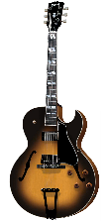  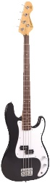  - Group instruments in different ways e.g. according to how they are played.  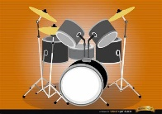  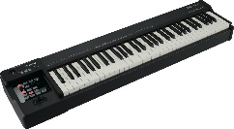  Keyboard drums bass guitar electric guitar  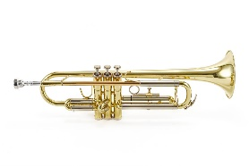  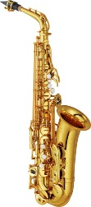  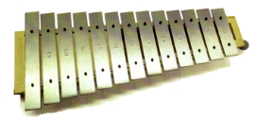  Saxophone trumpet glockenspeil
Pulse | The underlying steady beat of music. (This is what we may tap our foot or clap along with.)
Rhythm | Combinations of long and short sounds that convey movement.
Melody | Another name for a tune.
Dynamics | How loud or quiet the music is.
Tempo | An Italian word used to describe how fast/slow the music goes.
perform | Sing and play instruments.
performance | an act of performing a song or piece of music
audience | the group of people together in one place to listen to a song or a piece of music
notation | the link between sound and symbol.
graphic score | a way in which we can write music without having to write musical notes. You can use shapes and symbols in your graphic score to represent an instrument.
compose | To create and develop musical ideas and ‘fixing’ them.
improvise | To make up a tune and play it on the spot. There is an assumption that it can never be recreated.
Pitch | How high or low a sound is.
Pulse | The underlying steady beat of music. (This is what we may tap our foot or clap along with.)
Rap | a type of popular music with a strong rhythm in which the words are spoken, not sung
Reggae | Developed in the 1970s and originated from Jamaica, Reggae defined by Bob Marley. It  has a prominent bass beat and a strong off-beat usually played on the guitar .

