Key vocabulary
nutrition | Food necessary for health and growth.
nutrients | Useful substances that help animals and plants grow.
carbohydrates | These are the foods that give us energy. They are found in sugary and starchy foods.  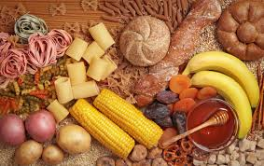
proteins | These are important so the body can grow, repair and build muscle.  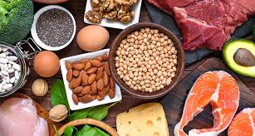
vitamins and minerals | Substances found in foods which keep us healthy. These are found in fruit and vegetables.  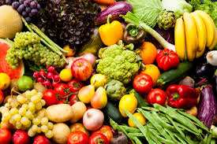
fibre | This lets food pass quickly through your body. It helps keep your digestive system in good working order.
skeleton | This supports and protects the body, allowing it to move.
bones | The hard parts inside your body which form your skeleton.
muscles | These are attached to bones and help us move.
joints | The place where 2 bones meet.

Animals including humans – Year 3
Significant scientist
Wilhelm Conrad Rontgen  (1845-1923)  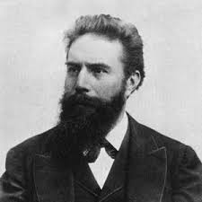 | Wilhelm Rontgen was a German physicist who discovered X-rays in 1895.  He was awarded many honours and won the Nobel Prize for physics in 1901.

Animals need to eat food to get the nutrients they need.

What type of foods should we eat to stay healthy?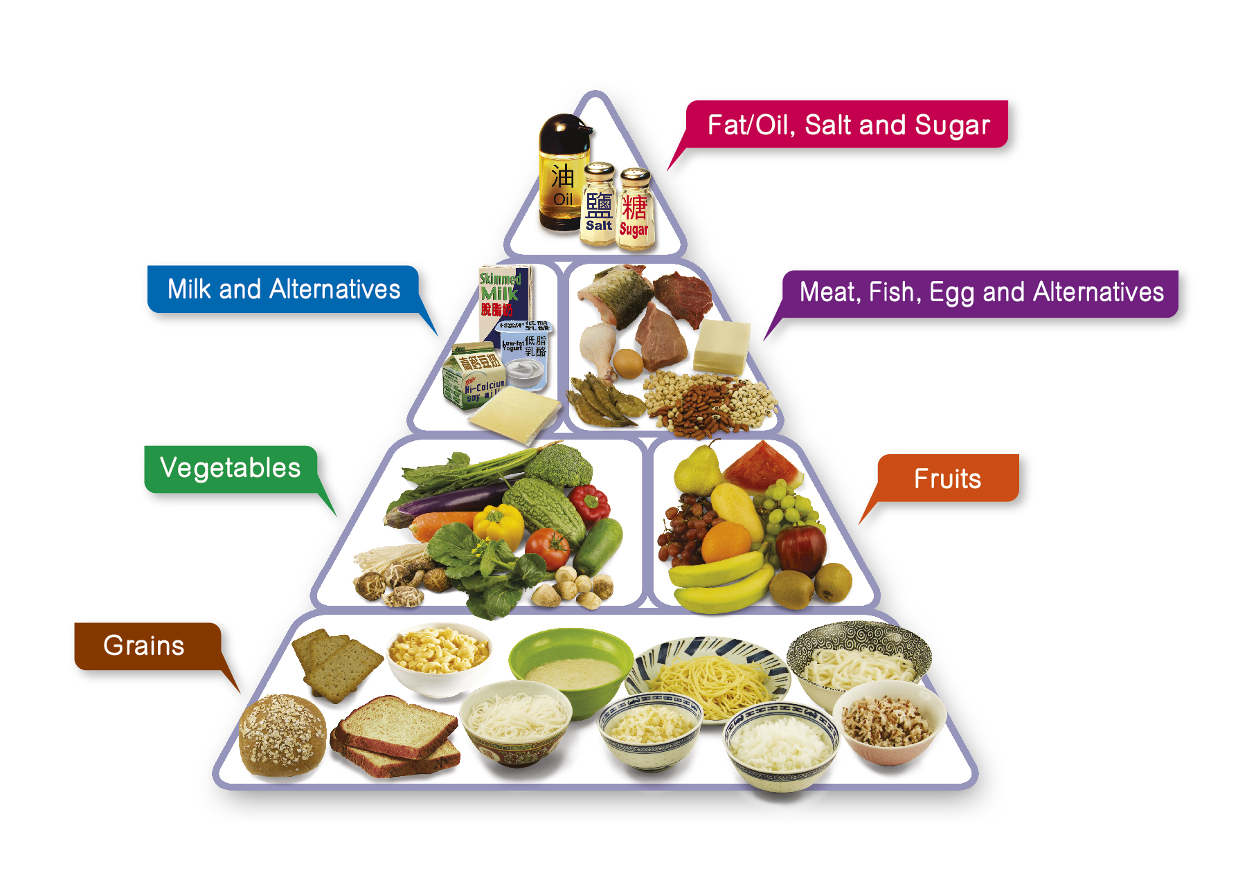
One piece of food can provide a range of nutrients.

© ECM Education Consultants 2019
The skull protects our brain.

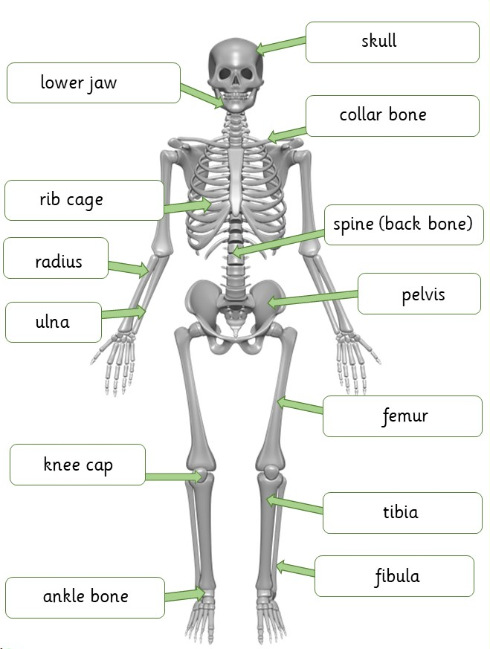
The bones in our legs support us and help us stand.
The bones and muscles in our legs help us move.

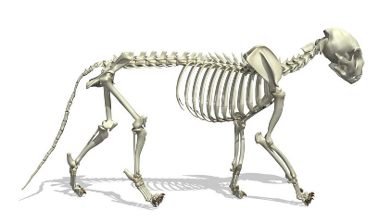
A cat skeleton

Key vocabulary
rock | A naturally occurring material made of minerals. They can be different sizes:  - stones  - pebbles  - boulders
fossil | The bones or other remains of living things are sometimes preserved in rocks as fossils.
soil | Ground up rock mixed with plant and animal remains.

Soils
© ECM Education Consultants 2019
The property of soils is affected by the:
- type of rock
- size of rock pieces
- amount of organic matter in it.

Peat  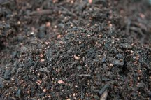 | - water-logged  - contains partially decomposed plant material  - soft and easily compressed
Sandy soil  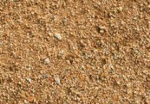 | - light and dry  - lots of air gaps so water drains through quickly
Chalky soil  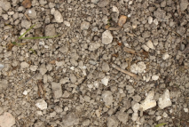 | - stony and water drains through quickly  - found in areas with lots of chalk
Clay soil  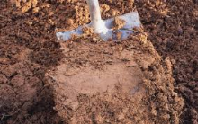 | - very sticky when wet  - a heavy soil  - water does not drain through it quickly
Rocks – Year 3
Significant scientists
Mary Anning  (1799-1847) | Mary Anning was an English palaeontlogist and fossil collecter. She became known around the world for important finds she made in Jurassic fossil beds in Dorset.
Holly Betts
PhD student, University of Bristol
Holly is a palaeobiologist. She is researching whether fossils are best for establishing a timescale for recent and ancient episodes in our evolutionary history.

Fossil formation
Fossils were formed millions of years ago.
1 Plants and animals died and sank to the seabed. | Animal fossil  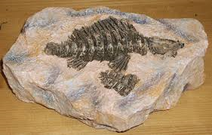  Plant fossil  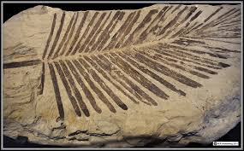
2 The soft parts decayed away leaving the hard parts.
3 The hard parts were covered and squashed by many layers of sand and other materials.
4 The animal/plant matter dissolves and is replaced by minerals, leaving a replica of the original bone called a fossil.
Types of rocks
Sedimentary
sandstone  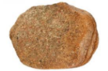 | limestone  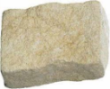
chalk  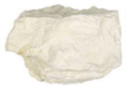 | Chalk is used for drawing because it is crumbly and soft.
Metamorphic
quartzite  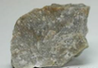 | slate  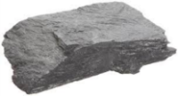
marble | Marble is good for gravestones because it does not rub away.
Igneous
basalt  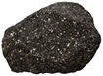 | pumice  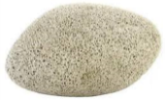
granite  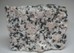 | Granite is good for worktops because it is hard and does not absorb water.

Words to describe the appearance of rocks:
crystals
hard or soft
texture
layers
absorb water or not
grains

Key vocabulary
roots | Anchor a plant in place. The roots also absorb water and nutrients from the soil.
stem/trunk | Transports water and nutrients around the plant. It also holds the leaves/flowers up in the air.
leaves | They use sunlight and water to produce the plant’s food.
photosynthesis | The way in which plants make food in their leaves.
pollen | This is a very fine powder that is produced by the male part of the flower.
pollination | When pollen is transferred to female parts of a flower. This can be done by wind or insects.
seed formation | Seeds can develop after pollination. They can be found in berries or fruits.
seed dispersal | Seeds can be dispersed in different ways, for example, wind, animals or water.
germination | When a seed sprouts a root and shoot.

How a plant takes in water
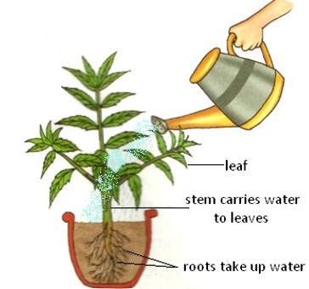
Plants – Year 3
Significant scientists
Joseph Dalton Hooker  (1817-1911)  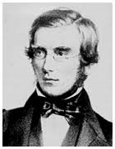 | Joseph Hooker was a doctor and travelled to many places. He was a plant collecter and botanist and brought many plants back to the UK. Joseph was interested in finding out why plants grow in the locations they do.
Professor Monique Simmonds  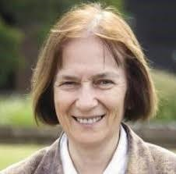 | Monique Simmonds is the deputy director of science at the Royal Botanic Gardens, Kew. She researches traditional and commercial uses of plants and fungi. Her work involves her promoting plant and fungal-based solutions to global challenges.
Plants need certain things to grow:

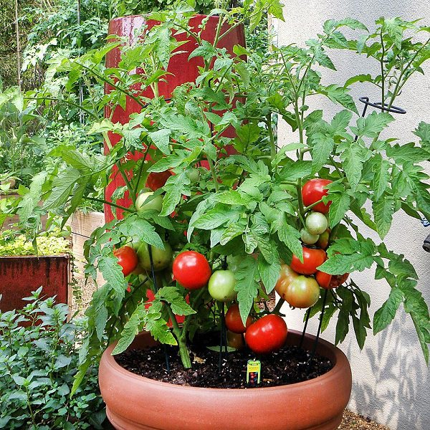
water
air
nutrients from the soil
room
light
Pollination
Insects like bees and wasps transfer the pollen from the male part of a flower to the female part of other flowers.

Methods of seed dispersal

 | by wind
 | on animal’s fur
 | by animal’s eating them
in water | when the seed pod explodes

© ECM Education Consultants 2019

Key vocabulary
light | We can see objects because our eyes can sense light.
dark | Darkness is the absence of light.
light source | Some objects emit their own light and are sources of light.  the sun lightbulbs candles
 | 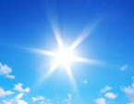 |  | 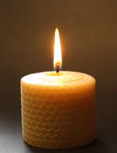
transparent | A material that is completely see through so all the light can pass through.
translucent | A material that lets some light through but not all of it.
opaque | A material that light cannot pass through. You cannot see through it.
shadow | These are formed when an object blocks light.
reflect | When light bounces off a surface.
mirror | A sheet of glass or metal that reflects light.

Sunlight
- The light from the sun can be dangerous.
- It can damage our eyes.
- We must never look directly at the sun.
- We can protect our eyes by wearing sunglasses or sunhats in bright sunlight.
© ECM Education Consultants 2019
Light – Year 3
Significant scientist
Justus von Liebig  (1803-1873)  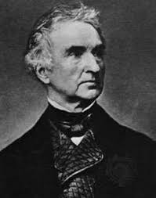 | Justus von Liebig was a German chemist. In 1835 he developed a process for applying a thin layer of metallic silver to one side of a pane of clear glass. This technique was soon adapted and improved, allowing for the mass production of mirrors.

Reflecting light
Shiny surfaces reflect light very well.
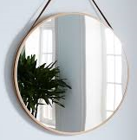 | 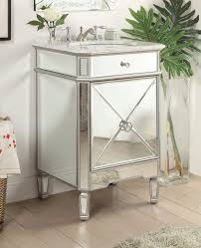
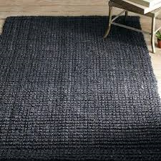 | 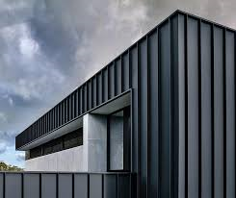  Matt surfaces don’t reflect light very well.

Why do we need light?
If it’s completely dark then there is no light.
We need light to see things.

The more light there is, the easier it is to see objects.

Shadows
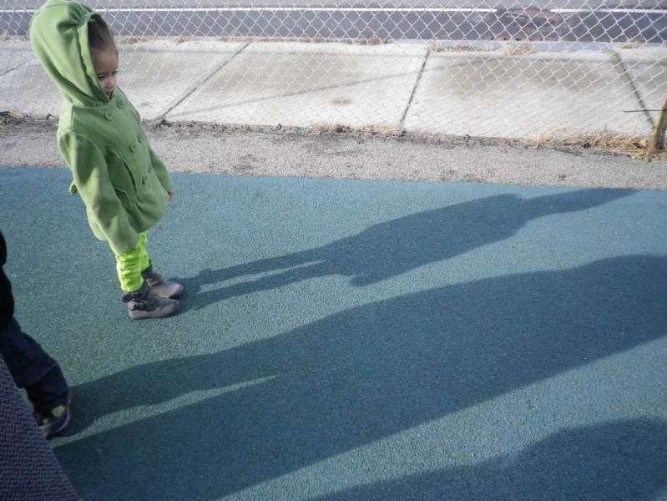 | Shadows are formed when an opaque object blocks the light.  The child is blocking the sun’s light.
We can change the size of the shadow by changing the position of the:  - light source  - object  - surface where the shadow is being made. | 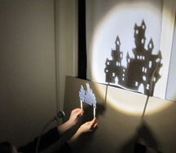

Key vocabulary
force | A force is a push or a pull.
magnetic force | An invisible force that attracts magnetic metals.
magnet | Magnets attract magnetic materials. Iron, nickel, cobalt and materials that contain these (e.g. stainless steel) are magnetic.
attract | To pull towards.
repel | To push away.
poles | Magnets have two poles, a north pole and a south pole.
contact force | Many forces need contact to act:
 | 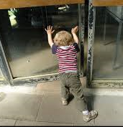 | 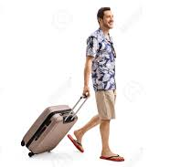
non-contact force | Magnetic force does not need contact and can act at a distance.

Objects moving on surfaces:
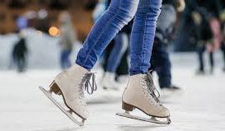 | Ice skates have a sharp blade. This helps them move better on ice.
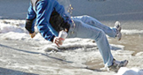 | It is much harder to walk on ice in trainers.
A bowling green is closely mown so the grass is short and the balls roll easily. | 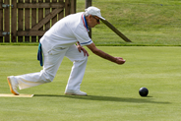
Forces and magnets – Year 3
Significant scientist
Michael Faraday (1791-1867)  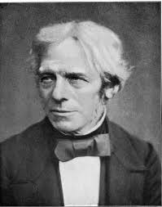 | Michael Faraday was an English scientist.  In 1831, he discovered electromagnetic induction. This was a very important discovery for the future of science and technology.

Types of magnets:
Bar  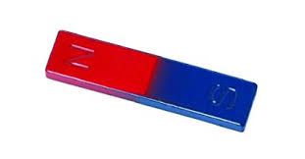 | Ring  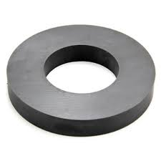
Button  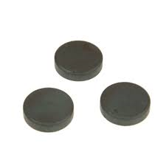 | Horseshoe  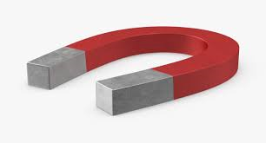

Magnets have two poles
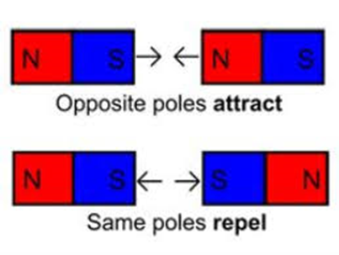
© ECM Education Consultants 2019
A magnet attracts magnetic materials.
These metals are magnetic:
iron nails  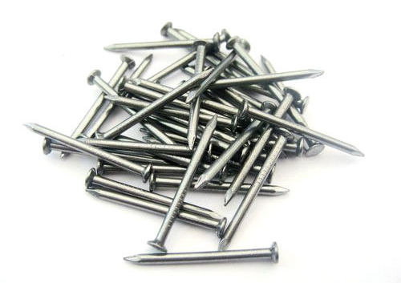 | nickel
 | 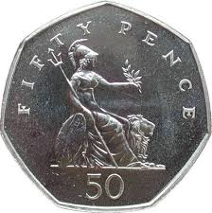 | 50p coins contain nickel
stainless steel  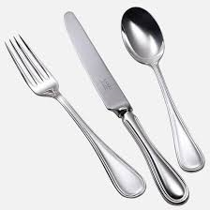 | steel  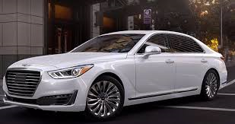

We can sort and classify materials as:
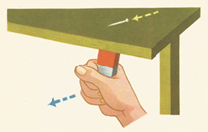
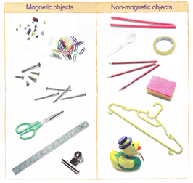
A magnet does not need to touch an object to attract it.

