Examples of habitats
woodland
Hedgehogs make a nest in leaves in woods.
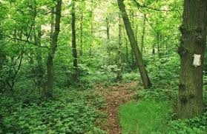
pond
Goldish can breathe in water.
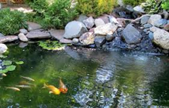
seashore
Crabs are omnivores and eat seaweed.
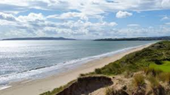
polar
Polar bears are carnivores and eat seals.
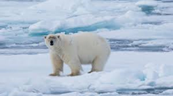
ocean
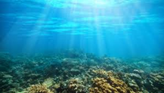
Stingrays live in saltwater.
rainforest
Spider monkeys find food high up in the treetops.
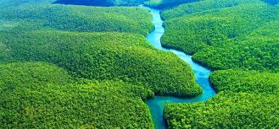
Living things and their habitats – Year 2
Key vocabulary
living | Living things are plants and animals.
 | 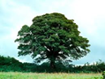
dead | Dead things include dead animals, plants and parts of plants and animals that are no longer attached.
 | 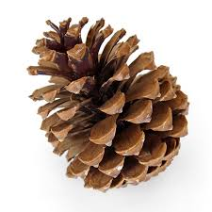 |  | 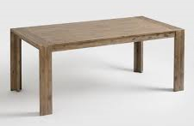
never been alive | Objects made of rock, metal and plastic have never been alive.
 | 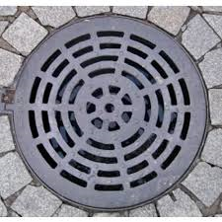 |  | 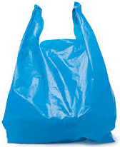
habitat | The place where an animal or plant lives and provides their basic needs – shelter, food and water.
micro-habitat | A very small habitat e.g. A log that woodlice live under.
food chain | These show how animals get their food from plants and other animals.
© ECM Education Consultants 2019
Examples of micro-habitats
in leaf litter  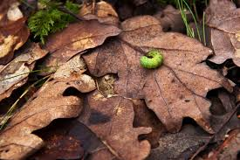  Caterpillars need leaves to eat. |  | under stones  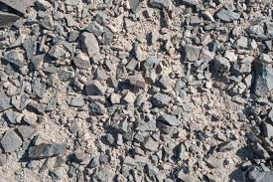  Woodlice can be found hiding under stones.
under logs  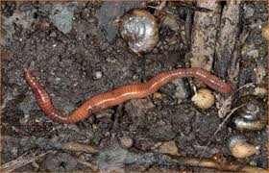  Worms prefer dark, damp places. |  | in shrubs  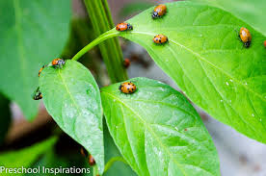  Ladybirds live in shrubs and trees.
Food chains

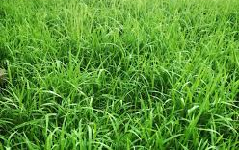  grass | grasshopper |  | 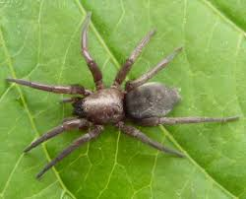  spider
The grass is eaten by the grasshopper.
The grasshopper is eaten by the spider.

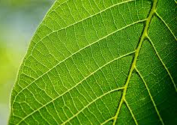  leaf | 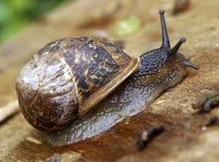  snail |  | 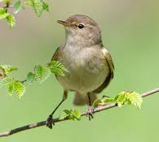  bird
The leaf is eaten by the snail.
The snail is eaten by the bird.

Plants can grow from seeds or bulbs -
seeds  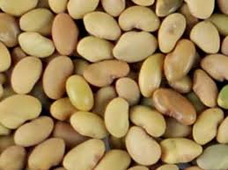 | bulbs  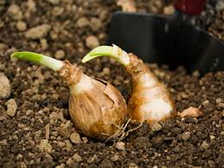
Seeds and bulbs germinate and grow into seedlings
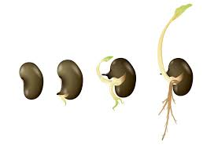
Seedlings then grow into mature plants

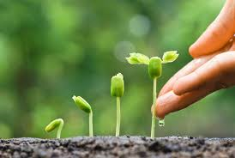
Seedling
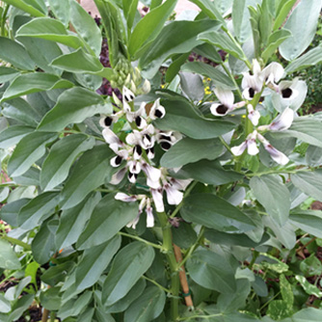
Mature plant

© ECM Education Consultants 2019
Plants – Year 2
Key vocabulary
seed | Part of a flowering plant that grows into a new plant.
bulb | A root shaped like an onion that grows into a new plant.
germinate | When a seed begins to grow its shoots. Seeds need warmth and water to germinate.
seedling | A young plant that has grown from a seed.
bud | Growth on a plant that develops into a stem, leaf or shoot.
flower | The part of a plant which is often brightly coloured and grows at the end of a stem.
fruit | Fleshy part of a plant that contains seeds or a stone.
berry | Small, juicy fruit without a stone.
root | The part of the plant that grows under the ground.
Significant scientist
David Douglas  (1799-1834)  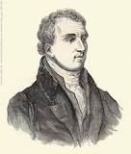 | David Douglas was a Scottish botanist, best known as the namesake of the Douglas-fir.  He worked as a gardener, and explored the Scottish Highlands, North America, and Hawaii.
Some plants grow best in full sun.  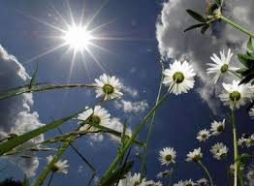 |  | Some plants grow best in the shade.  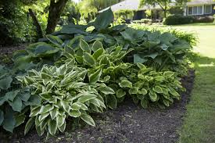
Some plants need lots of water.  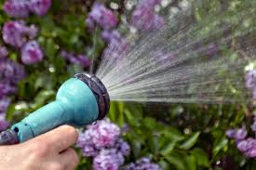 |  | Some plants don’t need much water.  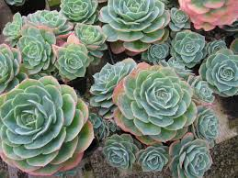
What does a plant need to grow and stay healthy?
light
water

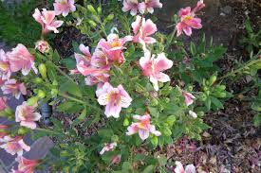
A suitable temperature
space

Some plants grow quickly and some grow more slowly.

Materials and their uses
Material | Properties | Uses
wood  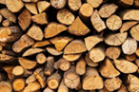 | opaque  hard  strong | table  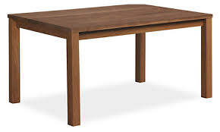
metal  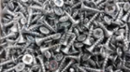 | shiny  smooth  reflective | fork  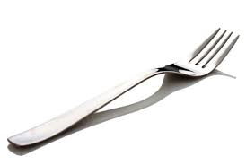
plastic  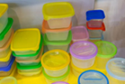 | waterproof  bendy  translucent | water bottle  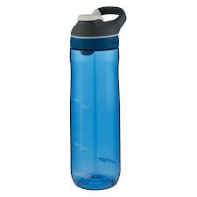
glass  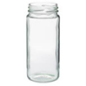 | transparent  waterpoof  hard | window  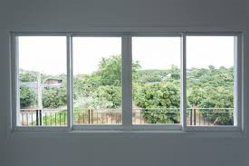
brick  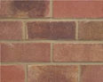 | hard  rough  dull | wall
rock  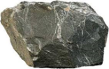 | strong  hard  rigid | fireplace  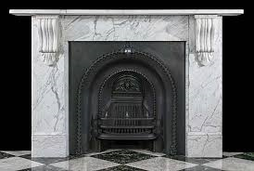
paper  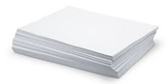 | tears easily  translucent  flexible | book
cardboard  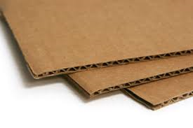 | dull  non-reflective  opaque | boxes
fabric  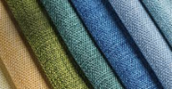 | flexible  Soft  absorbent | clothes  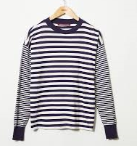
Uses of everyday materials – Year 2
Key vocabulary - properties of materials
transparent | Completely see-through
translucent | Let some light through but not completely see-through.
opaque | Not able to be seen through.
flexible | Bends easily without breaking.
rigid | Unable to bend or be forced out of shape.
reflective | Reflects light easily.
non-reflective | Does not reflect light.
absorbent | Able to soak up liquid easily.
Significant scientists
John Loudon McAdam  (1756-1836)  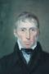 | John Loudon McAdam was a Scottish engineer who modernised the way we build roads.  He was the inventor of tarmacadam road surfacing – commonly called tarmac.
Julie Brusaw | Julie is one of the inventors of Solar Roadways.  Solar roadways use solar powered road panels to form a smart roadway.
Changing materials
squashing
Clay can easily be pushed and pulled.
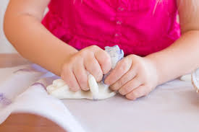
bending
Foil is bendy and waterproof.
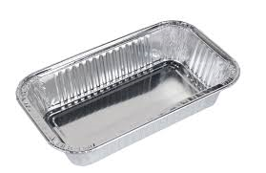
twisting
This plastic bottle’s shape can be changed.
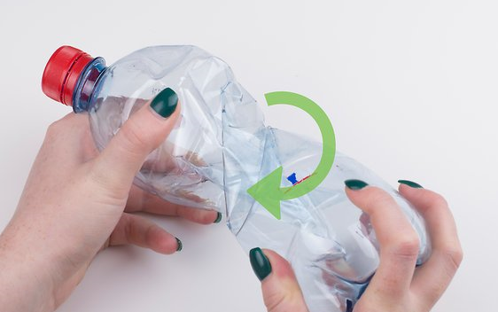
stretching
A balloon is very flexible.
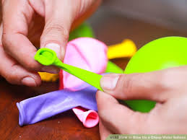
This chair has a fabric seat because it is soft.
It has wooden legs that are rigid and strong.

© ECM Education Consultants 2019

Animals including humans have offspring that grow into adults
lamb  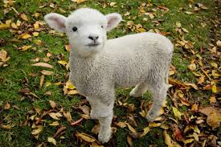 |  | sheep  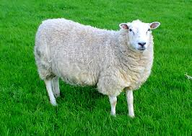
baby  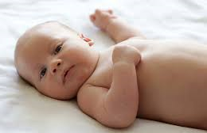 | toddler  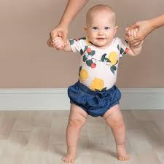 |  |  | child
adult |  |  | teenager
egg  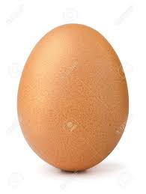 | chick  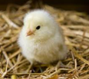 |  |  | chicken  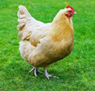
The young of some animals don’t look like their parents:
spawn  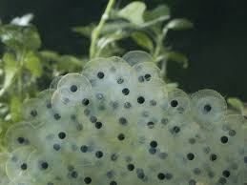 | tadpole  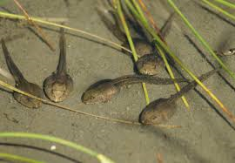 |  |  | frog  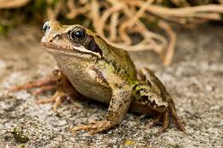
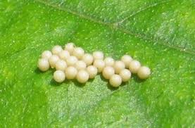  eggs |  | 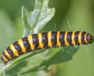  caterpillar
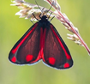  butterfly |  | 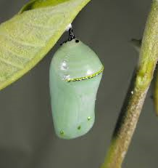  pupa
Animals including humans – Year 2
Key vocabulary
offspring | A person’s children or an animal’s young.
reproduction | The process where new animals, humans or plants are made.
growth | The process of getting bigger.
exercise | This is when you move your body physically to get fit and remain healthy. Our heartbeat increases when we exercise.
breathing | This is what we do to get oxygen in our bodies.
hygiene | Keeping clean to prevent illnesses and the spread of disease.
germs | A very small thing that can cause diseases. We cannot see them with our eyes.
disease | An illness which affects people, animals or plants.

Significant scientist
Dr Ernest Madu  (born 1960) | Dr Ernest Madu is a cardiologist. His work focuses on providing affordable healthcare in low-resource nations.
© ECM Education Consultants 2019

All animals including humans have these basic needs to survive:
water to drink
food to eat

shelter
air to breathe

To grow into healthy adults, animals including humans need:
exercise
good hygiene

right amount and types of food

The Eatwell plate
This shows the different food groups that make up a healthy diet. 