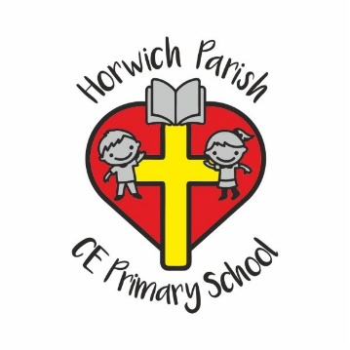
Dear Children,
We are looking forward to meeting you for the first time and getting to know all about you.
To help us to find out about the things you like, your talents and your family; we are asking you to make a special box, filled with lots of items that you can talk to us about.
Please ask a grown up to find an old shoe box or something similar. You could decorate the box in any way you like, but don’t forget to put your name on it.
Inside your box, you might put photographs of your family, pets and favourite activities and places. You might also like to draw pictures or make models – it’s up to you.
Best Wishes
Your Reception Teachers

