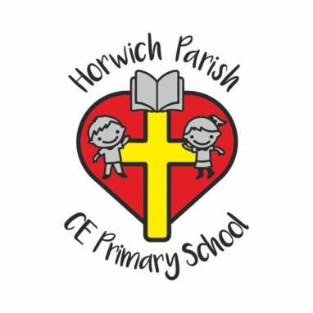

ParentPay

At Horwich Parish CE School we use ParentPay; a secure e-payment online system to pay for all school trips, clubs, tickets for productions, snacks, lunches and events.

When your child starts in Reception you will receive a letter confirming your username and password for ParentPay and instructions on using the site. It is very important to set up your account as soon as you receive this information, as we are unable to accept cash in school, so you must have an account to book onto any of the payment items listed above.

Once set up, you can bookmark the login page to your home screen for easy access on your smartphone (the vast majority of Android, iOS and Windows Phone devices are able to run ParentPay).

Payments can be made online using debit and credit cards, American Express or we can arrange for you to pay cash via Paypoint from over 28 000 shops across the country.

If you have any queries regarding your account, please contact the School Office.

Thank You

