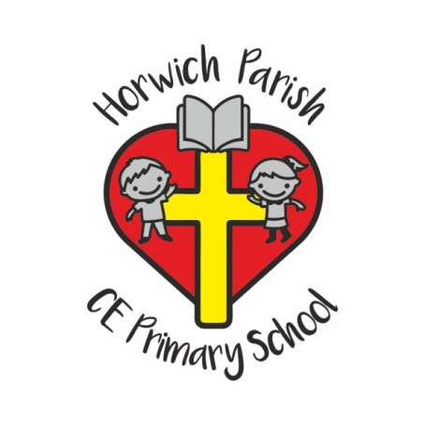

Reception Snacks

At Horwich Parish CE School we provide a range of healthy snacks each day. The snacks include:

- Wholemeal toast
- Cereal
- Fruit
- Yogurt
- Cheese & crackers

The cost for this is £1.25 per week and is to be paid in advance each term via ParentPay which is our secure e-payment online method which we use to pay for all school trips and events.

When your child starts in Reception you will receive a letter confirming your username and password for ParentPay and instructions on using the site.

Payments received via ParentPay by a set date will confirm your child’s participation in the snack scheme for each term.

Thank You

