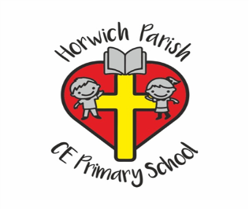

Our Mission statement
“God with us, lighting the way to love and respect”
We believe that at Horwich Parish CE Primary School our core purpose is the children. All decisions have the children at the heart. Opportunities for our children are guided by and learning from the example and teaching of Jesus Christ. These opportunities come from an ethos and curriculum that provide maximum learning experiences for each individual child, no matter what their particular learning abilities may be.
We provide a curriculum which the children enjoy and in which everyone can be good at something. We encourage the children to show tolerance and respect for each other, respect for themselves and those working with them. We expect the children to set themselves high standards, to take pride in their work, be good role models and do their best.
We provide curriculum enrichment activities including first hand experiences, creative opportunities, visits and visitors.
We will offer every child at Horwich Parish the chance to achieve as much as they are able. We will achieve high standards for all children, giving them secure foundations for future learning and success in life

