Curriculum Design

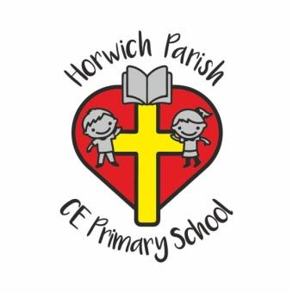
‘God with us, lighting the way to love and respect’
Our Vision is to be a school where everyone can achieve and
‘Let their light shine’ both individually and collectively as a community.
INTENT:
How we consider the quality of the curriculum in each subject as a driver of change
Our curriculum has been designed in collaboration with staff and children to ensure that it is unique and fitting for the needs and context of Horwich Parish School.
Our intent is to provide a curriculum which challenges, excites and ignites curiosity in our children and will enable them to become confident, lifelong learners, who achieve their potential within God’s loving family.

Our topic based curriculum exposes children to engaging experiences, inside and outside the classroom, whilst maintaining a focus on learning within discrete subject areas.
Learning is mapped out to ensure progression of skills, knowledge and vocabulary within and across year groups. Topics and lesson are planned to develop a deep contextual understanding and love of learning and allow children to commit knowledge to long term memory.

IMPLEMETATION:
How we consider the content and teaching sequence in each subject
At Horwich Parish, we value the different ways in which pupils learn and we plan lessons to account for these differences. Cross-curricular links ensure that pupils can draw upon knowledge from different subjects and understand how they relate to each other and everyday life and ensure these skills are committed to the long term memory. Age related expectations combine the acquisition of knowledge and development of skills to create a purposeful and exciting learning journey for every child.
Effective and engaging classroom environments support and enrich the children’s learning experiences and celebrate their achievements. The curriculum is designed to be inclusive and ambitious for all pupils regardless of their ability or needs.
We provide a variety of extra-curricular activities for pupils that enhance their learning experience. The activities range from after-school clubs, to educational trips and visits and guest speakers.. Extra-curricular activities are designed to enhance pupils’ learning experience and teach skills essential for life after school.
IMPACT:
How well our pupils learn and benefit from the content within our curriculum
Our curriculum has been designed to provide equal opportunities, so that all pupils will benefit in the following ways:
- Learning how to lead safe, healthy and fulfilling lives
- Showing resilience and ability to adapt to change
- Becoming responsible and respectful individuals who contribute to community living and the environment
- Achieving to the best of their ability
- Acquiring a wealth of knowledge and experience they can draw on effectively
- Finding a sense of belonging to the school and its community through God’s love

Curriculum development is an ongoing process, which will be reviewed regularly, informed by assessments, pupil voice, pupil outcomes and observations.

