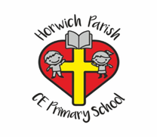

Evidencing the impact of Primary PE and Sports Premium at Horwich Parish CE School

2020 - 2021

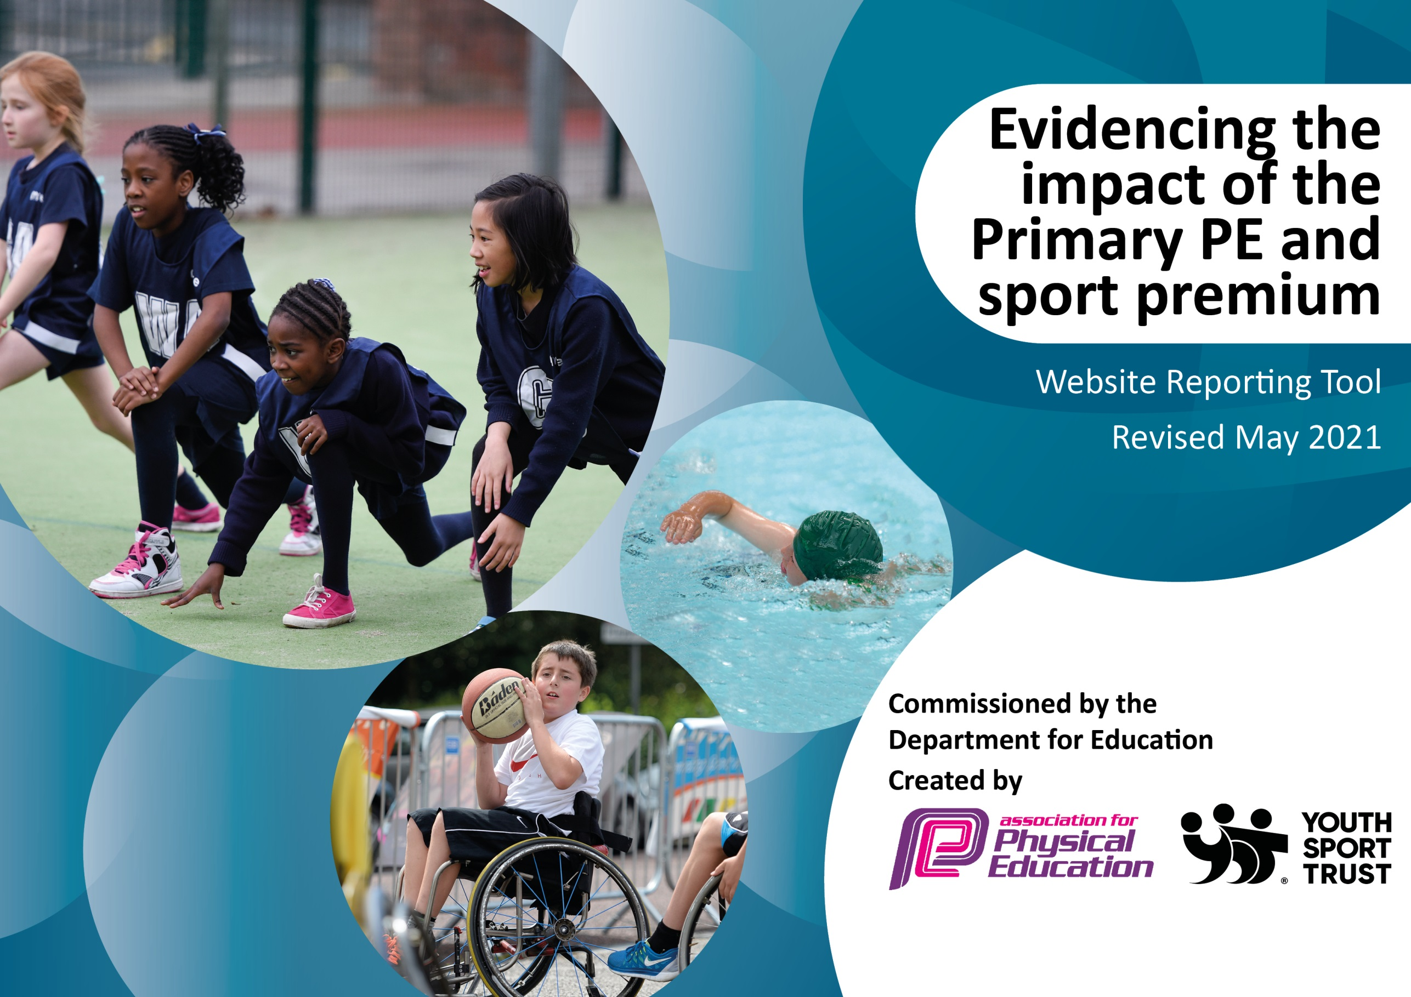

It is important that your grant is used effectively and based on school need. The Education Inspection Framework (Ofsted 2019 p64) makes clear there will be a focus on ‘whether leaders and those responsible for governors all understand their respective roles and perform these in a way that enhances the effectiveness of the school’.

Under the Quality of Education criteria (p41) inspectors consider the extent to which schools can articulate their curriculum (INTENT), construct their curriculum (IMPLEMENTATION) and demonstrate the outcomes which result (IMPACT).

To assist schools with common transferable language this template has been developed to utilise the same three headings which should make your plans easily transferable between working documents.

Schools must use the funding to make additional and sustainable improvements to the quality of Physical Education, School Sport and Physical Activity (PESSPA) they offer. This means that you should use the Primary PE and sport premium to:

- Develop or add to the PESSPA activities that your school already offer
- Build capacity and capability within the school to ensure that improvements made now will benefit pupils joining the school in future years
- The Primary PE and sport premium should not be used to fund capital spend projects; the school’s budget should fund these.
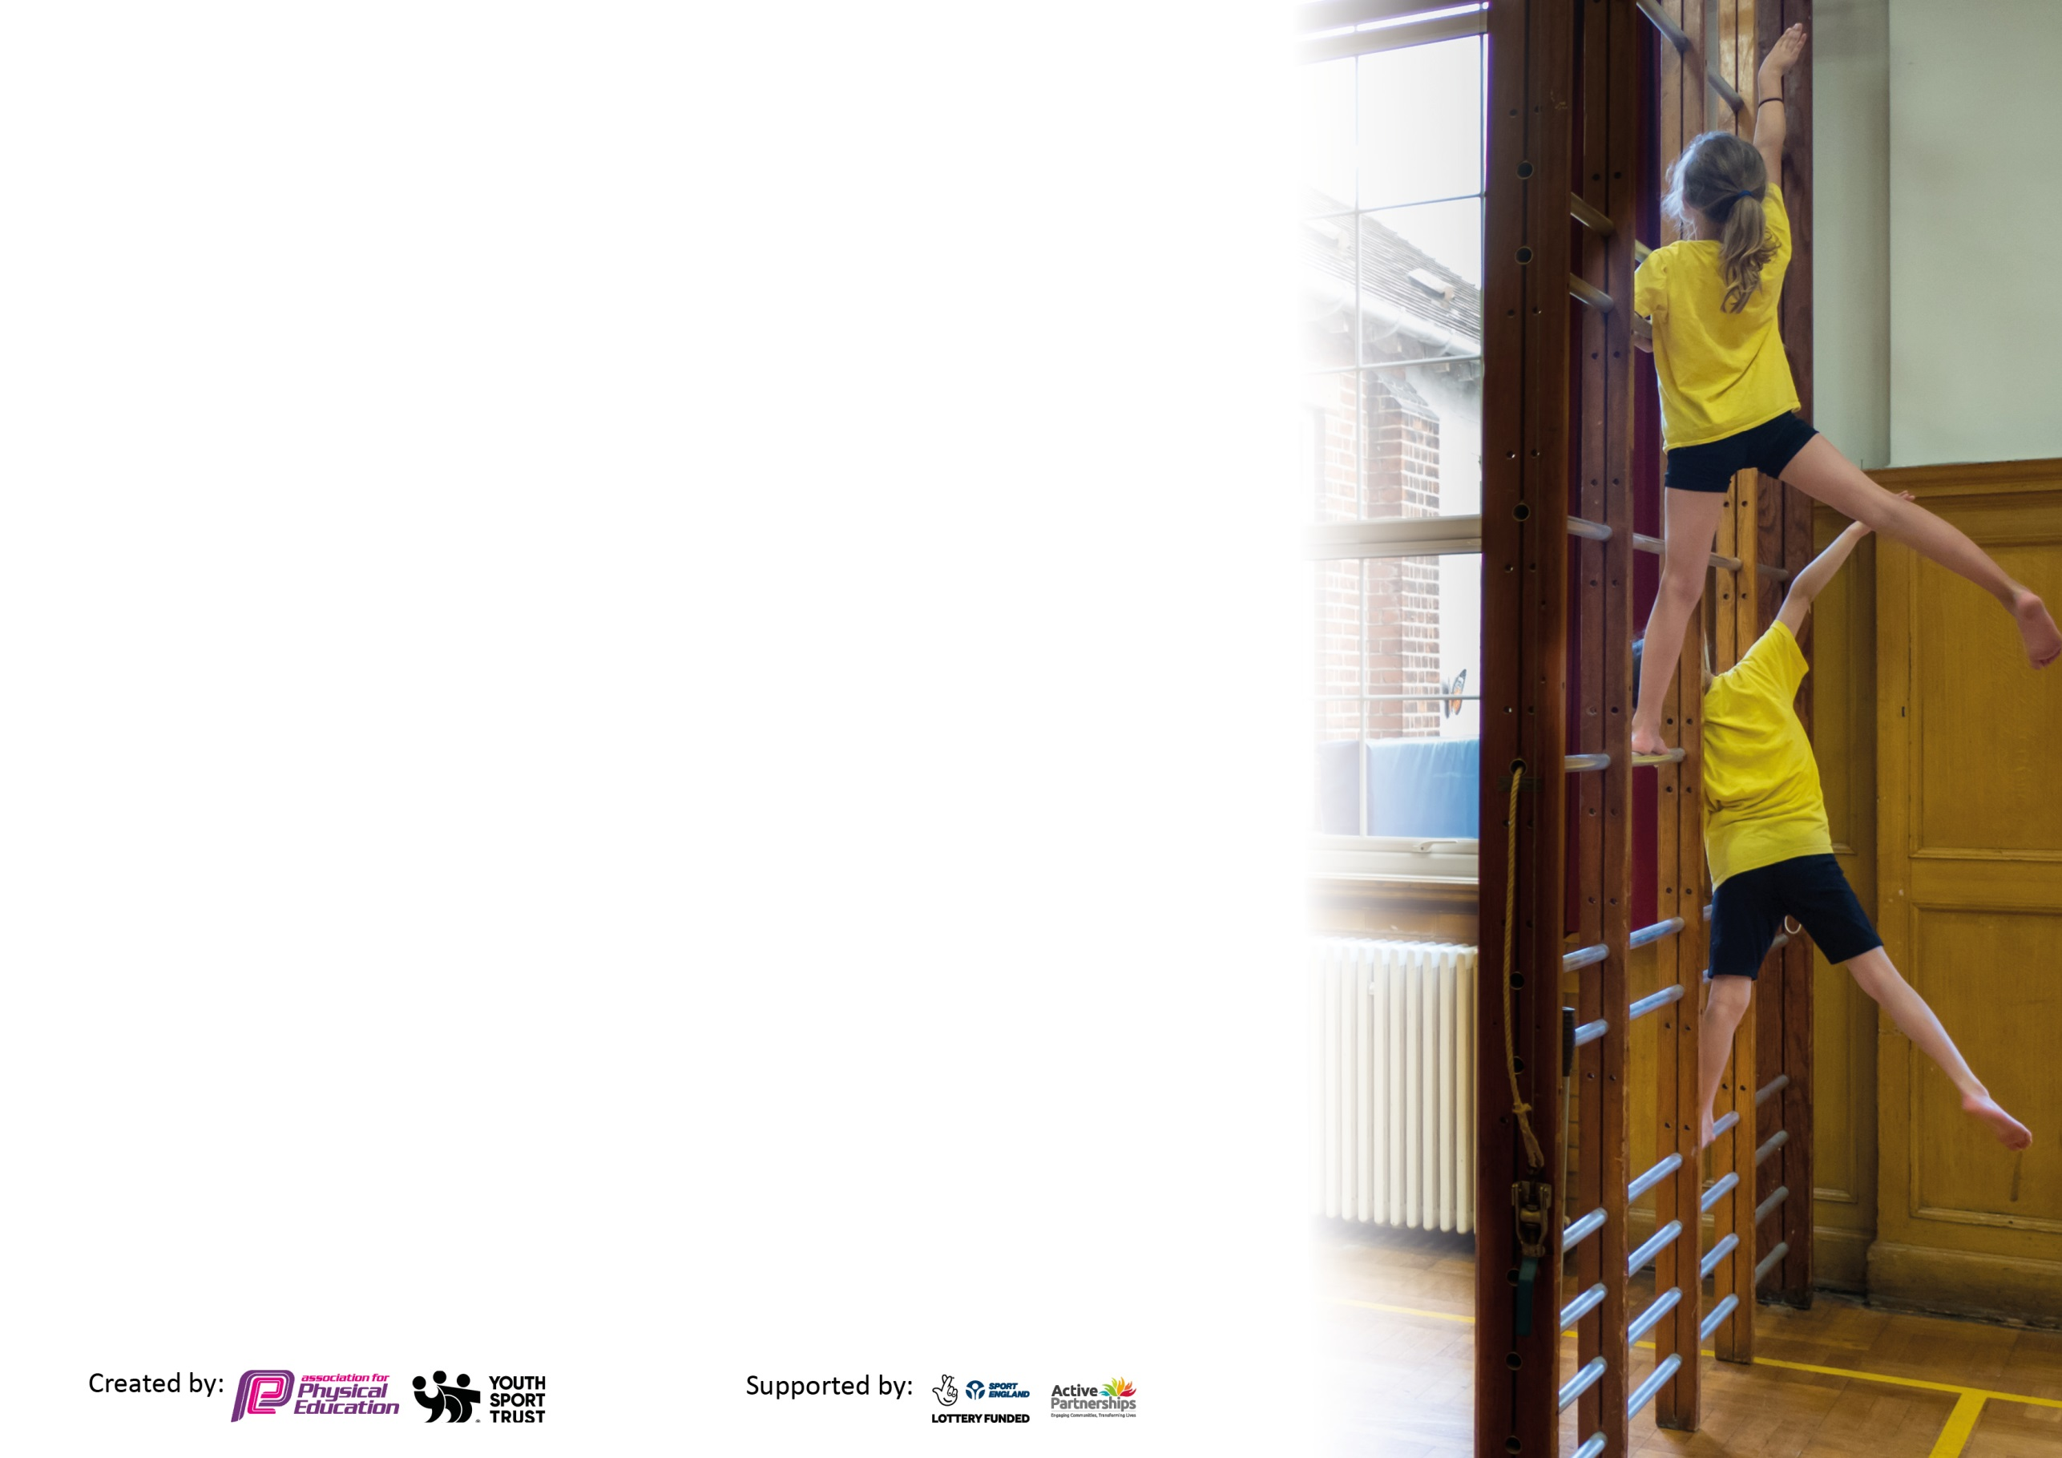
Please visit gov.uk for the revised DfE guidance including the 5 key indicators across which schools should demonstrate an improvement. This document will help you to review your provision and to report your spend. DfE encourages schools to use this template as an effective way of meeting the reporting requirements of the Primary PE and sport premium.

We recommend you start by reflecting on the impact of current provision and reviewing the previous spend.

Schools are required to publish details of how they spend this funding, including any under-spend from 2019/2020, as well as on the impact it has on pupils’ PE and sport participation and attainment by the end of the summer term or by 31st July 2021 at the latest.

We recommend regularly updating the table and publishing it on your website throughout the year. This evidences your ongoing self-evaluation of how you are using the funding to secure maximum, sustainable impact. Final copy must be posted on your website by the end of the academic year and no later than the 31st July 2021. To see an example of how to complete the table please click HERE.

Please note: Although there has been considerable disruption in 2020 it is important that you publish details on your website of how you spend the funding - this is a legal requirement.
Support for review and reflection - considering the 5 key indicators from DfE, what development needs are a priority for your setting and your pupils now and why? Use the space below to reflect on previous spend and key achievements and areas for development.

N.B. In this section you should refer to any adjustments you might have made due to Covid-19 and how these will influence further improvement.
Key achievements to date until July 2020: | Areas for further improvement and baseline evidence of need:
- New Skills Based curriculum introduced September 2019.  - Key PE coaches have continued to work in school one day per week.  - Teaching staff are now more confident in the delivery of the PE curriculum.  - Coaches provide structured lunchtime sporting activities when in school.  - After school clubs have taken place in a reduced capacity as a result of Covid - 19.  - Yoga has been introduced by a qualified Yoga instructor throughout the Summer Term.  - Orienteering is now being delivered across school following on from a purchase of resources and CPD for all teaching staff.  - A reduced inter-school sporting competition calendar has been successfully completed with the school taking part in a range of virtual and face to face competitions | - Sports council to take on more roles across school. Ideas could be: taking more of an acting role organising intra-school competitions, health week organisation, reporting the school on recent competitions/ upcoming competitions, encouraging healthy living (objective rolled over as a result of Covid – 19)  - Skills based curriculum to be continued – New staff to observe Key PE coaches teaching PE.  - Monitor the delivery of the PE curriculum throughout the academic year 2021 – 2022. Careful monitoring of progression of skills across all year groups will be necessary.  - Sporting opportunities for all children to be added to in addition to current curriculum (boxing, fencing, circuit training).  - A return to a full inter-school sporting calendar.  - A return to a full intra-school sporting calendar to be led by the children of Horwich Parish.

Did you carry forward an underspend from 2019-20 academic year into the current academic year? NO
Total amount carried forward from 2019/2020 £0
+ Total amount for this academic year 2020/2021 £ 19,344.00
= Total to be spent by 31st July 2021 £13,285
Meeting national curriculum requirements for swimming and water safety.

N.B Complete this section to your best ability. For example you might have practised safe self-rescue techniques on dry land which you can transfer to the pool when school swimming restarts.
Due to exceptional circumstances priority should be given to ensuring that pupils can perform safe self rescue even
if they do not fully meet the first two requirements of the NC programme of study.
What percentage of your current Year 6 cohort swim competently, confidently and proficiently over a distance of at least 25 metres?  N.B. Even though your pupils may swim in another year please report on their attainment on leaving primary school at the end of the summer term 2021.  Please see note above. | 100%
What percentage of your current Year 6 cohort use a range of strokes effectively [for example, front crawl, backstroke and breaststroke]?  Please see note above. | 100%
What percentage of your current Year 6 cohort perform safe self-rescue in different water-based situations? | 100%
Schools can choose to use the Primary PE and sport premium to provide additional provision for swimming but this must be for activity over and above the national curriculum requirements. Have you used it in this way? | No

Action Plan and Budget Tracking
Capture your intended annual spend against the 5 key indicators. Clarify the success criteria and evidence of impact that you intend to measure to evaluate for pupils today and for the future.

Academic Year: 2020/21 | Total fund allocated: £19,644 | Date Updated: 20/7/21
Key indicator 1: The engagement of all pupils in regular physical activity – Chief Medical Officers guidelines recommend that primary school pupils undertake at least 30 minutes of physical activity a day in school |  |  |  | Percentage of total allocation:
 |  |  |  | 36 %
Intent | Implementation |  | Impact
Your school focus should be clear what you want the pupils to know and be able to do and about  what they need to learn and to  consolidate through practice: | Make sure your actions to achieve are linked to your intentions: | Funding allocated: | Evidence of impact: what do pupils now know and what can they now do? What has changed?: | Sustainability and suggested next steps:
All children at Horwich Parish should complete two weekly PE lessons which should consist of the teaching of specific skills and physical exercise.  Children should learn to be naturally active and seek own opportunities to exercise and live healthy lives. | Key PE coach / class teachers ensure that all children engage in physical exercise and that PE lessons are suitably challenging.  So children have the opportunity for physical activity in the classroom, the school has purchased a year-long licence to imoves which acts as an interactive tool that contains a wide range of physical and mental health activities that can be completed both in class, in the wider school setting and at home. | £6,895 | Children take part in appropriately challenging physical activity during their twice weekly PE lessons.  Children choose to engage in physical activity during their own time.  Imoves is used in school as an extra resource so that physical activity takes place at regular intervals throughout the school week (including during daily lesson time). | Continue to subscribe to Imoves as a resource to be used in class settings.  Post covid restrictions could allow for the reintroduction of play leaders who could lead structured break time games.
Key indicator 2: The profile of PESSPA being raised across the school as a tool for whole school improvement |  |  |  | Percentage of total allocation:
 |  |  |  | 39 %
Intent | Implementation |  | Impact
Your school focus should be clear what you want the pupils to know and be able to do and about  what they need to learn and to  consolidate through practice: | Make sure your actions to achieve are linked to your intentions: | Funding allocated: | Evidence of impact: what do pupils now know and what can they now do? What has changed?: | Sustainability and suggested next steps:
The profile of sport and healthy/ active living should always be promoted as a priority within school. Children should be encouraged to live active lives through regular exercise and a developed understanding of healthy living.  Children should be given the opportunity to engage in competitive sport through inter and intra sporting competition. | Skills taught through PE lessons – led by both teaching staff and Key PE sports provide all children at Horwich Parish with the skills to participate in and compete in sporting activities.  Virtual inter-school competition and face to face (Summer Term) competitions arranged throughout the year.  After school clubs led by qualified sports coaches were ran throughout the Summer Term for children in separate bubbles. | £1,075 (Inter-Competition SLA)  £6400 – part of Key PE SLA | The profile of sport at Horwich Parish has been maintained through the continued skills based curriculum.  Inter school competition has continued throughout the academic year (either remotely or face to face) complying with all government guidelines.  Children have had the opportunity to attend after school sports clubs allowing them to further engage with sporting activities. | Following on from the easing of Covid-19 restrictions in school, daily mile will be reintroduced as a whole school initiative where all children will complete one mile of the playground daily.  Ways of making the daily mile a more competitive event for UKS2 to be discussed and supported by Key PE as part of their renewed SLA 2021 - 2022

Key indicator 3: Increased confidence, knowledge and skills of all staff in teaching PE and sport |  |  |  | Percentage of total allocation:
 |  |  |  | 33%
Intent | Implementation |  | Impact
Your school focus should be clear | Make sure your actions to | Funding | Evidence of impact: what do | Sustainability and suggested
what you want the pupils to know | achieve are linked to your | allocated: | pupils now know and what | next steps:
and be able to do and about | intentions: |  | can they now do? What has
what they need to learn and to |  |  | changed?:
consolidate through practice:

For children to access a curriculum that ensures skills are developed progressively and that children understand the skills they develop combined with associated vocabulary.  Staff have the skillset enabling them to effectively deliver the PE curriculum. | Key PE sports SLA continued throughout the 20 – 21 academic year in order to allow teachers who required continued support developing their ability to teach PE observe coaches. | £6400 | Children are able to specifically talk about the skills they have developed and can use associated vocabulary. | New staff commencing employment at Horwich Parish to access CPD via Key PE throughout the next academic year.
Key indicator 4: Broader experience of a range of sports and activities offered to all pupils |  |  |  | Percentage of total allocation:
 |  |  |  | 27 %
Intent | Implementation |  | Impact
Your school focus should be clear | Make sure your actions to | Funding | Evidence of impact: what do | Sustainability and suggested
what you want the pupils to know | achieve are linked to your | allocated: | pupils now know and what | next steps:
and be able to do and about | intentions: |  | can they now do? What has
what they need to learn and to |  |  | changed?:
consolidate through practice:

Additional achievements:  Children at Horwich Parish should have to opportunity to engage in the widest variety of sporting activities as possible to allow them to enjoy new sports and discover activities they would like to spend time developing further. | The PE curriculum led by the staff at Horwich Parish and KE PE ensure that children have been taught and taken part in a wide variety of sporting activities.  A professional Yoga instructor was employed and has delivered ten weeks of yoga sessions to all children at Horwich Parish.  Horwich Parish bought a full orienteering resource pack which included CPD for all teaching staff. Following on from this, all children at Horwich Parish are following an updated orienteering scheme of work bespoke to the individual school. | £5,220 | Children at Horwich Parish are now familiar with Yoga, its physical and mental benefits (comments made by the children during pupil interviews) and explain that they have enjoyed the sessions. A number of children have looked into continuing Yoga outside of school.  Children at Horwich Parish have commenced working through the new orienteering scheme of work. The nature of a large part of the curriculum allows for the children to be extremely active as they run to find different markers around the school grounds. Many of the sessions have a competitive nature to them which the children have said that they enjoy. | As part of the continued SLA with Key PE, a new range of sporting activities are to be introduced to the school’s PE curriculum throughout the 2021 – 2022 academic year.

Key indicator 5: Increased participation in competitive sport |  |  |  | Percentage of total allocation:
 |  |  |  | 4%
Intent | Implementation |  | Impact
Your school focus should be clear | Make sure your actions to | Funding | Evidence of impact: what do | Sustainability and suggested
what you want the pupils to know | achieve are linked to your | allocated: | pupils now know and what | next steps:
and be able to do and about | intentions: |  | can they now do? What has
what they need to learn and to |  |  | changed?:
consolidate through practice:

All children should have to opportunity to participate in competitive sport. Inter-school and intra-school competitions should be planned throughout the year including the widest possible variety of sporting competitions. | Horwich Parish continued their SLA with the Horwich and Blackrod Sports Association throughout the 2020 – 2021 academic year in a reduced capacity as a result of Covid-19.  Many sporting competitions were held virtually enventually leading to face to face competition throughout the Summer Term. | £850 | Horwich Parish entered all the available virtual competitions throughout the academic year. A wide variety of children were able to compete against other schools as a result of the different competitions offered. | Horwich Parish to return to full inter-school and intra-competition throughout the next academic year with a heavy focus on inclusive competition.

Signed off by
Head Teacher: | Debbie Mills
Date: | 20-7-21
Subject Leader: | Stephen Banner
Date: | 20/7/21
Governor: | Susan Baines
Date: | 13th October 2021

