Ppppkhgdedsa

**English**

**Write a formal journal linked to Shackleton’s expedition**

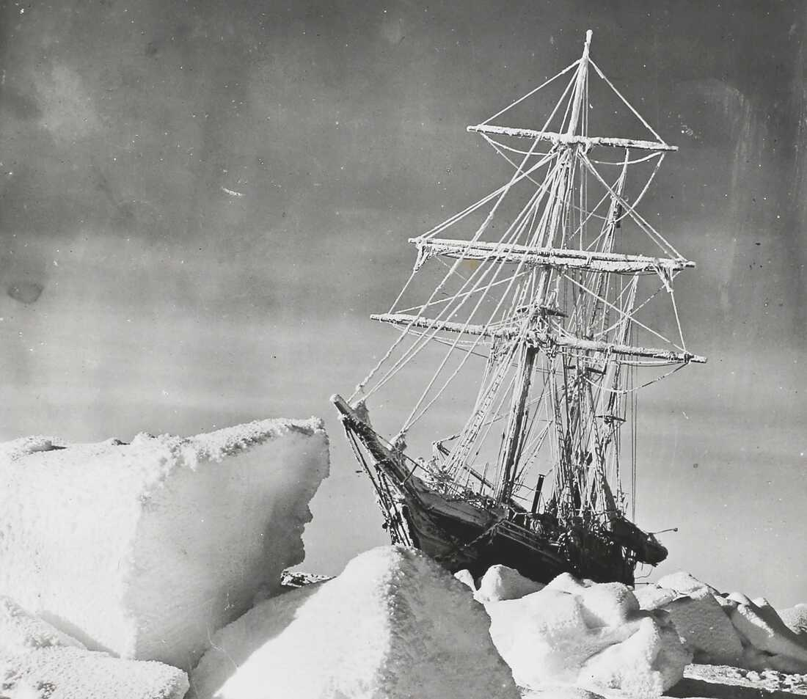

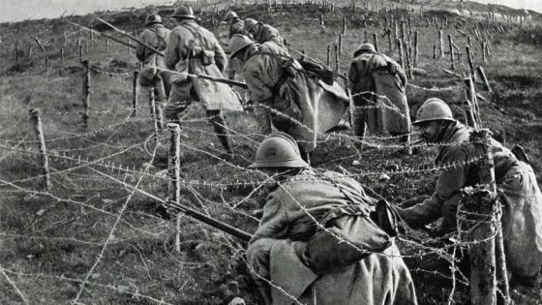

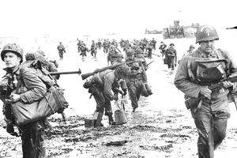

**Art**

**Drawing**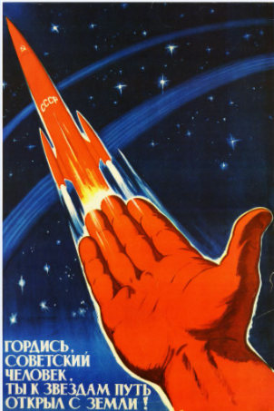

**Science**

**Evolution**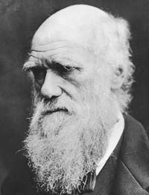

**Religious Education**

**Why is the Torah so important for Jewish People?** 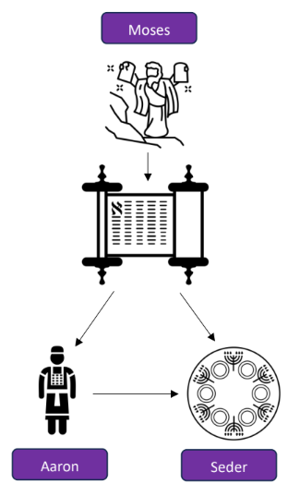

PSHE

Puberty

**Computing Coding**



**P.E.**

**Yoga**

**Sending and Receiving**

History

Placing events in chronological order

Using primary and secondary sources

How did the war affect the people of Horwich?

**Maths**

**Fractions**

**Decimals**

**Percentages**

