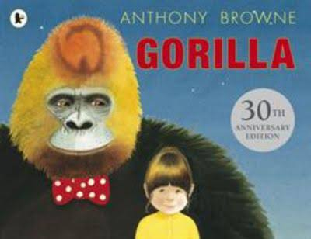Ppppkhgdedsa

**History**

**Ancient Egypt – study of an early civilisation**

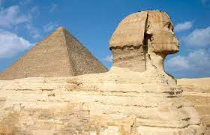 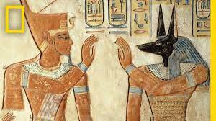

**Music**

**Wider Opportunities**

**Brass**

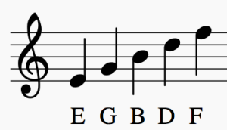

**Science/DT**

**Electricity**

**&**

**Torches**

**English**

**Narrative**

**Poetry**

**Character description**

**Focus Text: Gorilla by Anthony Browne**

**Art**

**Egyptian artwork**

**Religious Education**

**The Creation Story**

**PSHE**

Keeping/Staying Safe

Keeping/Staying Healthy

**Computing**

**Digital Citizenship**

Online Safety

**P.E.**

**S.A.Q**

**Speed**

**Agility**

**Quickness**

**Maths**

**Place Value**

**Addition & Subtraction**

**Area**