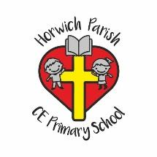
SMSC Subject Statements

Subject: Key Stage 1 Reading

Spiritual

- Reading supports spiritual development by engaging children with poetry, fiction and drama. Through reading and listening to stories read aloud by adults, children can explore and discuss the feelings and values found in a wide range of genre.

Moral

- Reading supports moral development by enabling children to look, discuss and evaluate a range of social and moral issues found in a wide range of stories.

Social

- Through carefully chosen books, reading supports social development by helping children to explore and discuss social interactions between characters.

Cultural

- Reading and listening to carefully selected stories supports cultural development by exposing children to a range of cultures, beliefs and lifestyles.

