Ppppkhgdedsa

**Religious Education**

Jesus – Son of God

Judaism

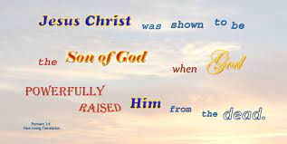

**P.E.**

**Sending and Receiving**

**Science**

**Electricity**



**Music**

**4R Wider Opportunities Brass**

**4B Stop!**

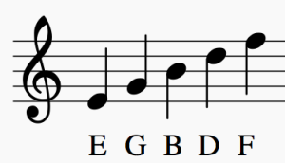

**DT**

**Textiles**



**English**

* **Newspaper Report**
* **Diary Entry**
* **Poetry**

**PSHE**

* Computer Safety
* Diversity

**Computing**

* **Coding**
* **Computer Science**

**Maths**

* **Multiplication & Division**
* **Length and Perimeter**

