Key vocabulary
digestive system | The organs in your body involved in the digestion of food.
digestion | This is the way the body breaks down food so the body can absorb it.
herbivore | Animals that only eat plants.
carnivore | Animals that eat other animals.
omnivore | Animals that eat both plants and animals.
producer | All green plants can make food in their leaves. They are the only producers of food.
consumer | Animals that eat plants in a food chain.
predator | Animals that catch and eat other animals.
prey | Animals that are hunted and eaten by predators.
food chain | Animals eat plants or other animals. The way this happens is shown in a food chain.

Teeth
Humans have 4 types of teeth:
- incisors – used for cutting
- canines – rip and tear food
- molars and premolars – for grinding and chewing food

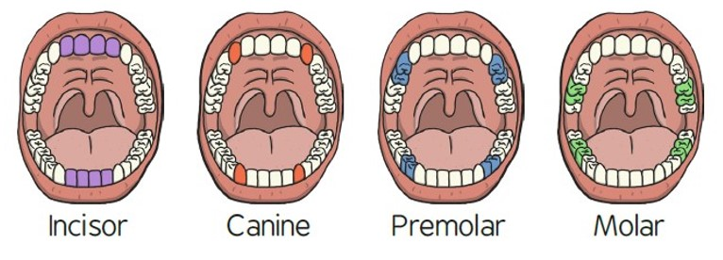
Animals including humans – Year 4
Significant scientist
William Beaumont  (1785-1853)  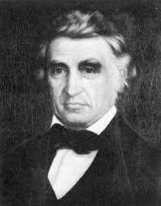 | William Beaumont was a surgeon in the U.S. Army. He carried out lots of experiments and research on human digestion.  As a result, he provided the world with new information about the digestive process in living human beings.

Food chains
= is eaten by
algae  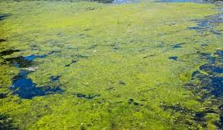 | tadpole  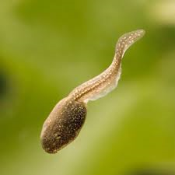 | fish | stork  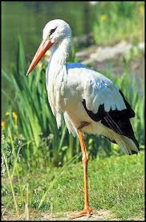
grass  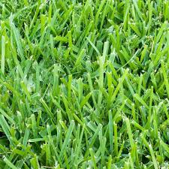 | beetle | mouse  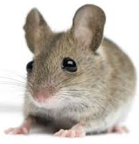 | fox

Lion skull
Lions are carnivores. They have big canine teeth to help them catch their prey.
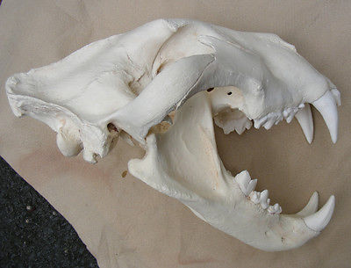
© ECM Education Consultants 2019
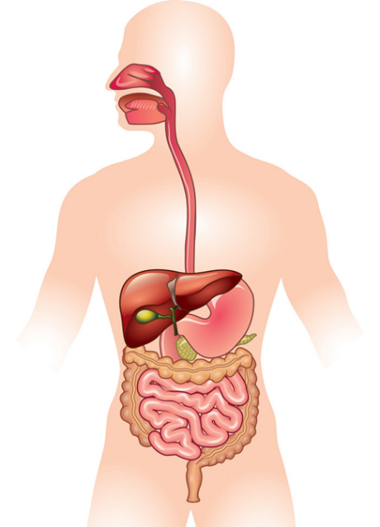
anus
large intestine
stomach
rectum
small intestine
oesophagus
mouth and teeth
The main parts of the digestive system:
- Food enters the body through the mouth
- The teeth start to break the food down. Saliva is added and the tongue rolls the food into a ball.
- After swallowing, the food passes down the oesophagus to the stomach
- In the stomach the food is broken down further by being churned around and some chemicals are added.
- Food passes into the small intestine. Here nutrients are removed from the food to be used elsewhere in the body.
- The rest passes into the large intestine where water is removed to be used elsewhere in the body.
- What is left is then stored in the rectum until it leaves the body through the anus when you go to the toilet.

