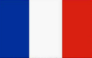
FRANCE
KNOWLEDGE ORGANISER
Overview |  |  | Human Geography |  |  |  | Key Vocabulary  France  Europe  Mediterranean  North Sea  Paris  Overseas Territory  Alps  Bay of Biscay  Pyrenees  Euro  Tourism  Coastline  Marseille  Region  Lyon  Atlantic Ocean
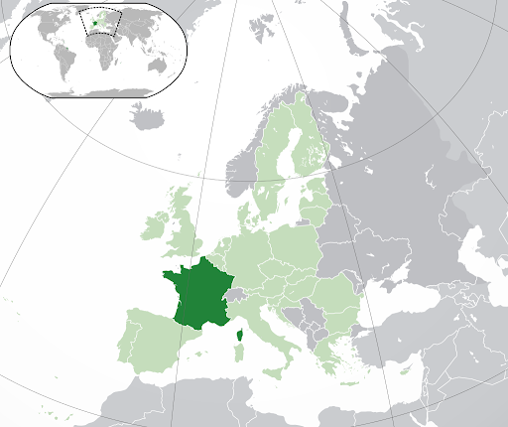  ‘  -France is a country in western Europe.  -It is bordered by Italy, Germany, Belgium, Spain, Monaco, Andorra, Luxembourg and Switzerland.  -It also has large coastlines on the Mediterranean Sea and Atlantic Ocean.  -France covers an area of 551,695 sq. km. It is the 3rd largest European country.  -About 67 million people live in France. The capital city is Paris.  -France also includes several overseas territories, e.g. French Guiana and Reunion.  --‘[-[‘- |  |  | France has a long and rich history, and a culture which has developed over hundreds of years. It is a major economic centre and is also a tourism hotspot – millions visit Paris and other areas of France every year.
 |  |  | Population |  | -The population of France is around 67 million people. This makes it the fourth most populous country in Europe. The population density is 118 people per square kilometre. This is the 15th highest population density in Europe.
 |  |  | Settlements |  | -The most populous and capital city of France is Paris. It has a population of over 10.5 million people (metro area). Other large settlements include Lyon, Marseille, Toulouse and Nice. Many settlements are found around rivers and along the coast.
 |  |  | Economic Activity |  | -France is a part of the European Union and its currency is the Euro. It is one of the G7 - countries with the most advanced economies in the world. Alongside Germany and the UK, it is considered a ‘European powerhouse.’
 |  |  | Resources/ Trade |  | -France is a large worldwide exporter of vehicles, food and wine, medicines and chemicals. French is spoken in many countries around the world, helping France’s strong trade links with many other countries.
Physical Geography
-France is located on western mainland Europe.  -France is relatively flat in the north and west, but has the mountainous Pyrenees in the south and Alps in the west.  -France also includes the five overseas territories of Guadeloupe, Martinique, French Guiana, Mayotte and Reunion.  -France has generally warm summer and cool winters. The temperature is warmer in the south, with hot summers along the Mediterranean.  -Rainfall is heaviest in the areas around the Pyrenees mountains.  -The longest river entirely in France is the Loire, which is 1012km long. However, the Rhine is partially in France, and is 1230km long.  -France is close to the United Kingdom, via the English Channel. At the Strait of Dover, the countries are separated by only 18 miles of sea! | 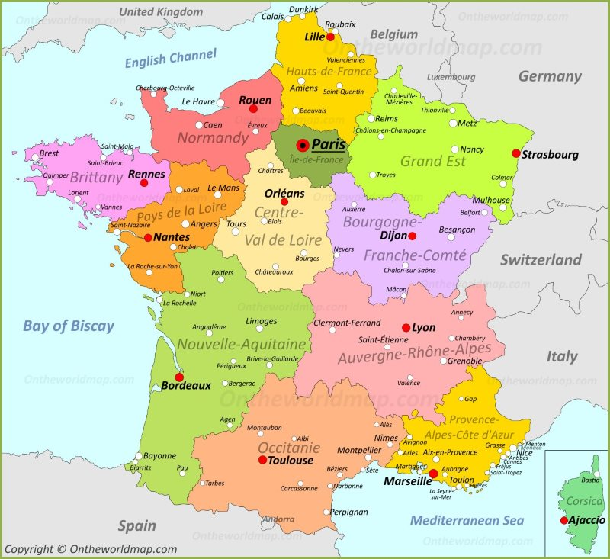  -France is broken up into 18 regions – 13 are on the mainland and 5 are overseas regions. Each region is broken down into several districts. |  | Comparison with the UK
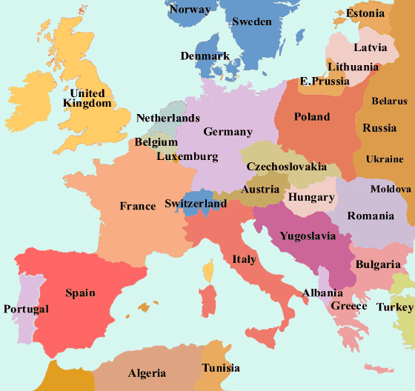
-Both countries are in Europe: the UK is slightly north of France, across the English Channel.
-Due to its slightly more southerly position (closer to the Equator) France is generally a little warmer than the UK.
-France is larger than the UK – 551,695 sq. km compared to 243,610sq km.
-Slightly more people live in France than the UK – 67 million people compared to 66 million people.
-Paris and London are similar in size – which is bigger depends on definition.
-France has much higher mountains than the UK. Mt. Blanc is 4810m high. The highest in the UK is Ben Nevis, at only 1,345m.
-France is on mainland Europe, the UK isn’t.

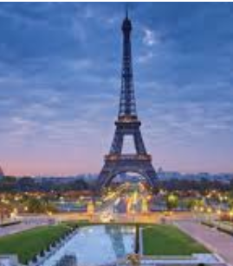
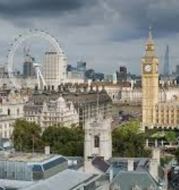

1940 CE WWII – Germany invades France.
1986 CE Spain joins the European Union.
843 CE Frankish Empire divided (would later become France & Germany)
1066 CE Duke William of Normandy conquers England.
509 CE Clovis I unites all Frank tribes – first King of the Franks.
52 BCE Julius Caesar conquers Gaul (modern France)
1789 CE French Revolution begins
1815 CE Napoleon defeated at Waterloo.
1453 CE Hundred Years War with Britain.
476 CE The Western Roman Empire collapses.
300 CE The Franks begin to settle the region.
400 BCE Celtic tribes settle in the region.
600 BCE Colony of Massalia founded by Ancient Greeks.
France Timeline

