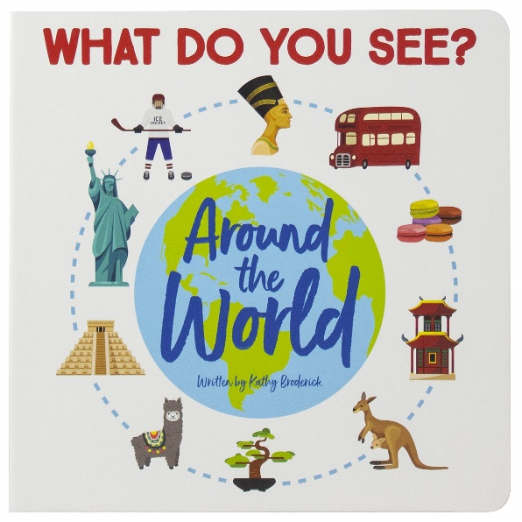

Geography

Around the world

To locate different countries and describe the characteristics and features of each place.

PSHCE

Relationships

be able to name a range of feelings

understand why we should care about other people’s feelings

be able to see and understand bullying behaviours

know how to cope with these bullying behaviours

RE

Jesus – friend to everyone

enjoy these stories of Jesus’ Miracles and to increase the children’s awareness that Jesus was an extraordinary person who welcomed everyone as a friend

**Around the world**

**Spring 1**

**Curriculum Newsletter**

DT

Fruit and vegetables

Describe fruits and vegetables and explain why they are a fruit or a vegetable.

* Name a range of places that fruits and vegetables grow.
* Describe basic characteristics of fruit and vegetables.
* Prepare fruits and vegetables to make a smoothie

Maths

Money

Multiplication and division

Length and height

Mass, capacity and temperature

**English**

**Writing a letter to the Earth.**

**Writing a non chronological report**

Commas in a list

Conjunctions

Similes

Verbs and adverbs

Collective nouns

Science

Animals including humans

How do animals and humans change as they grow

Dow e all grow the same

What do humans need to grow

What is a healthy diet?

Why do we need to have good hygiene